What’s in Your Name?

Create a poetic acronym using letters in a first name to describe one’s self.

15 min 1 participant

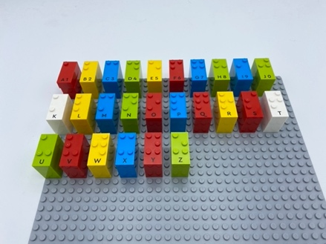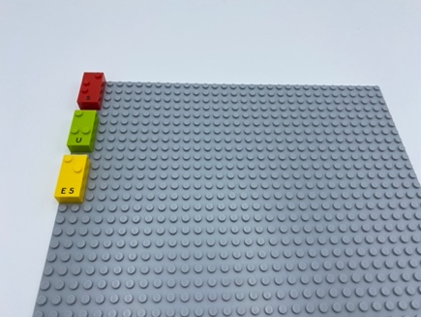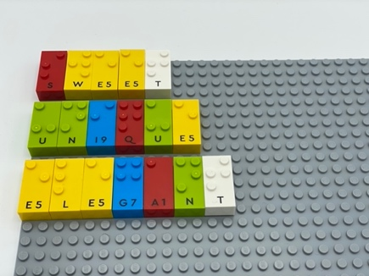

Let’s play
- Write your name vertically (in a column) on the base plate
- Use the first letter in your name to think of a word that describes you
- Write it horizontally using the brick already on the base plate
- Continue to do so with each letter in your name

How to prepare
- 2 base plates
- All the letter bricks

Prepare one of the base plates alphabetically for ease in finding letter bricks.

Facilitation tips
- Ask the child to help you preparing the alphabetical base plate. It could be a warm-up activity!
- Ask the child to find adjectives which describe them best starting with their name’s letters : acronyms are a poetic way to write a text!
- Read aloud famous examples of acronyms so children will have a better understanding of this specific way of writing.

Possible variations
- Make it a collaborative activity: player 1 writes an acronym describing an animal. Player 2 reads all the words and tries to guess what animal it is.

- Children will develop these holistic skills
- COGNITIVE: Discover the function of the written word: Participate in the writing of certain words
- CREATIVE: Write as a leisure activity
- EMOTIONAL: Implement an artistic project
- SOCIAL: Gradually use appropriate vocabulary and/or ratings to describe a situation, present an argument
- PHYSICAL: Develop tactile tracking skills: Use both hands to track across broken lines on a page and identify space between lines, Relocate hands to beginning of next line

Did you know
- Actively engaging, when learners have choice - big or small - to make about the content or processes involved in their learning. Active engagement comprises the three dimensions of feelings about learning (behavioral) and thinking and processing about and within the learning context (cognitive). The most effective integrated pedagogies attend to all three dimensions.

