Place in Squares

5 min 1 participant

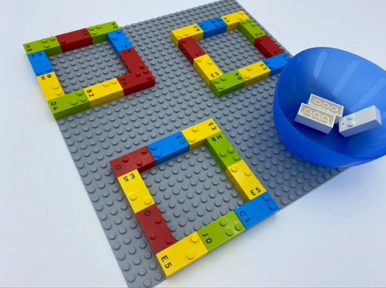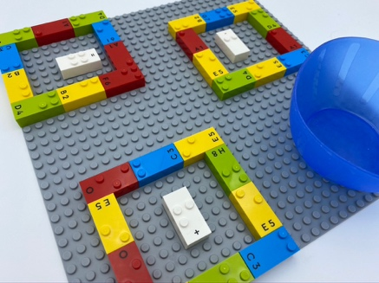

Let’s play
- Search for square on the base plate.
- Place one brick from the bowl inside each square.
- Do not let the brick touch the walls of the square!

How to prepare
- 1 base plate
- 33 random bricks
- 1 bowl
On the base plate, build the first square in the top left edge: start from left to right with 3 horizontal bricks, adding 2 vertical bricks below each end. Complete the square by adding a bottom horizontal line of 3 bricks.
Add 2 more squares anywhere on the base plate.
Place the 3 remaining bricks in a bowl.

Facilitation tips
- Encourage the child to use both his hands.
- Ensure the child understands the difference between inside and outside the square.
- Encourage child to imagine different scenarios: i.e. these 3 dogs are tired. Help each of them find a doghouse.
- Deepen recognition of basic shapes in 3 dimensions first, then in 2 dimensions with LEGO on a base plate.

Possible variations
- Change the number of squares.
- Place more than one brick in each square…
- Build squares and rectangles and choose in which shape to place the brick.

Children will develop these holistic skills
- PHYSICAL - Discover the “spatial organization of a page”
Repeat a gesture for stabilization and effectiveness
- COGNITIVE - Recognize spatial relationships
Recognize, classify and sort basic shapes in 2 dimensions

Did you know
- Playful experiences support children in developing the skills to serve them, their communities and society through a lifetime.
- Playful experiences in the early years allow you to acquire the critical skills for learning throughout a lifetime.

