Find Your Letter

5 min 1 participant

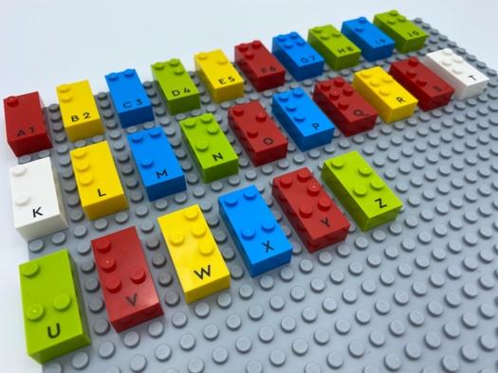

Let’s play
- Find the first letter of your name on the base plate.
- Say the letter.
- Say your name.

How to prepare
- 1 base plate
- All the letter bricks
Place the bricks on the base plate in alphabetical order.

Facilitation tips
- It is easier to locate the first brick on the base plate when the bricks start in the top left corner.
- Capital letter signs are not used in this activity because it can be difficult for a young child to understand the concept of using 2 bricks for one letter
- Ask “How much did you get it right?”
- Suggest to imagine a faster way to find a letter.

Possible variations
- The same activity can be done choosing children’s names in the class and finding the initial letter sound of their names.
- Find the first letter of words in a given category (animals, fruits…).

Children will develop these holistic skills
- COGNITIVE - Discover the function of the written word: identify letters and their order and then, depending on the letter, its sound value
- EMOTIONAL - Develop motivation to read for pleasure
- CREATIVE - Utilize adapted games/materials during free time
- PHYSICAL – Improve auditory discrimination skills: discriminate sounds in words (syllables)

Did you know
- An activity is meaningful when the child can relate new experiences to something already known. In play, children often explore what they have seen and done, or noticed others do, as a way of grasping what it means. By doing so, they can express and expand their understanding through a variety of media, symbols and tools.

