The Longest Word

30 min 2 participants

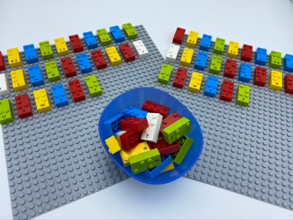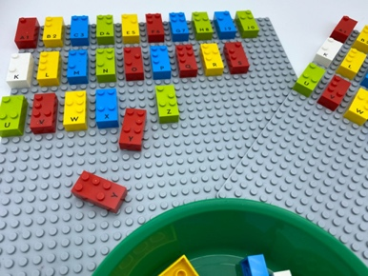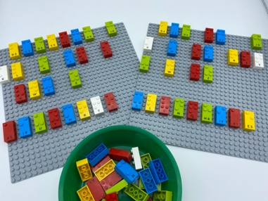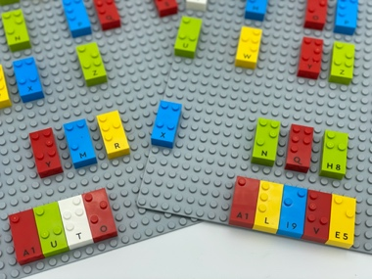

Let’s play
Both players
- Take turns picking a brick from the bowl, read the letter.
- Find your duplicate letter on your base plate and place it at the bottom until 8 letters have been chosen.
- Spell the longest word possible with your 8 letters.
- Make the longest word and you win the game.

How to prepare
- 2 base plates
- Letter bricks (3 sets of each letter of the alphabet)
- 1 bowl
Place one set in the bowl and give each player a set to arrange on their base plate.

Facilitation tips
- Ask “How did you organize your bricks? What was your strategy?”.
- Some children may be able to perform the activity mentally and won’t need to write the word.

Possible variations
- Use a timer.
- Change the number of letters.
- The 8 letters can be selected in advance by the educator.
- Add a selection of unusual letters.

Children will develop these holistic skills
- COGNITIVE - Discover the function of the written word: participate in the writing of certain words
- CREATIVE - Perform operations on letters and word syllables: remove, add, reverse, locate, substitute
- EMOTIONAL - Develop vocabulary and understanding in reading
- PHYSICAL – Develop tactile tracking skills: locate, read an identified number of word or letter on a line
- SOCIAL - Request and accept help from others, use peers as a resource

Did you know
- An activity is actively engaging, when learners have a choice - big or small - to make about the content or processes involved in their learning

