Perfect 10

20 min 2 participants

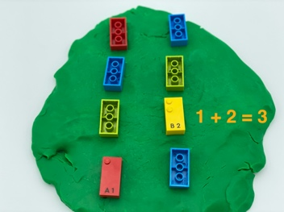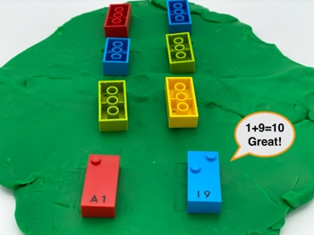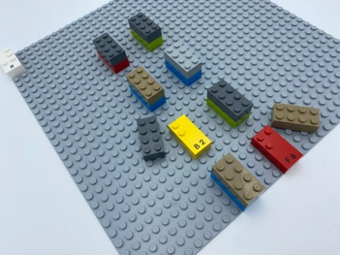

Let’s play
Player 1
- Turn over 2 bricks and place them in their original spots.
Both players
- Read the number bricks.
- Add the numbers together.
Player 1
- Keep the bricks if the 2 numbers add up to 10.
- Replace the bricks in the same place if they do not add up to 10.
Player 2
- Continue the activity following the same instructions.

How to prepare
- 8 number bricks “1”, “2”, “3”, “4”, “6”, “7”, “8”, “9”
- Playdough
Spread out a large flat piece of play dough or modeling clay.
Arrange the bricks upside down in 2 rows on the modeling clay.
The aim is to have the bricks so that the studs cannot be felt. This can be achieved by rolling out a piece of playdough and placing the bricks on the dough upside down. Alternatively, without play dough, attach the number bricks to the baseplate and hide it by placing another brick on top (for example a classic 2x4 LEGO brick so all the tops feel the same).

Facilitation tips
- Explain that we are not going to put the number sign in front of each brick.
- Ask “What is your strategy to remember the position of the bricks?”.

Possible variations
- Change the number of bricks.
- Change number to be reached, multiplication instead of addition…

Children will develop these holistic skills
- COGNITIVE - Calculate with numbers: read, write and interpret mathematical statements involving addition (+), subtraction (–) and equals (=) signs.
- PHYSICAL - Learn through action, observation, analysis of personal action and observed activity Learn to preplan actions.
- EMOTIONAL - Identify socially acceptable and unacceptable behavior.
- CREATIVE - Invent a variety of activities with one set of objects.

Did you know
- Guided play can lead to higher gains on literacy, numeracy, social skills and self-regulation skills than instruction or free play alone.
- A fun activity can create learning environments and empower young children to realize their potential.

