Identify Individual Letter

10 min 1 or 2 participants

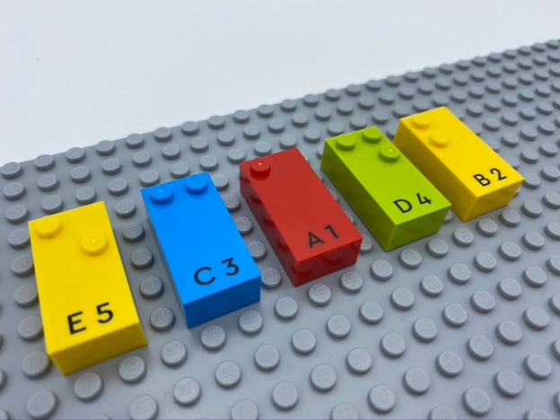

Let’s play
- Point your index finger to letter “B”.
- Pick up letter “C”.
- Replace letter “B” by letter “C”.
- Attach letter “B” in the right top corner of the base plate.
- Attach letter “C” on top of letter “B”.

How to prepare
- 1 base plate
- 5 bricks: “A”, “B”, “C”, “D”, “E”
Align the bricks in random order on the base plate.

Facilitation tips
- Propose they take a letter and put it on their head, under the table…
- Ask “How can you make the activity more fun?”.

Possible variations
- Increase the number of players (an adult may check if the answers are correct).
- Change the number of letters.
- Ask the child to select the letters they want to play with.

Children will develop these holistic
- COGNITIVE - Recognize and name the majority of letters of the alphabet
- PHYSICAL - Read each letter, combine several letters, produce a series of identical letters
- EMOTIONAL - Solicit information/assistance from appropriate persons in various settings
- CREATIVE - Engage in solitary play activities for an appropriate amount of time

Did you know
- Engaged learners demonstrate motivation and commitment towards their learning, often extending themselves beyond set goals and expectations.

