6-Car Parking Lot

15 min 2 participants

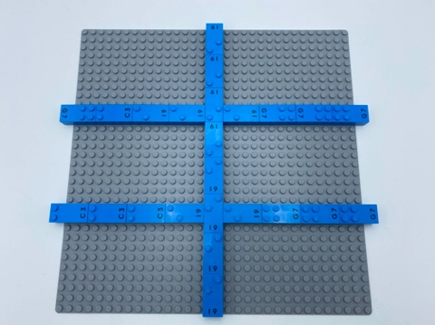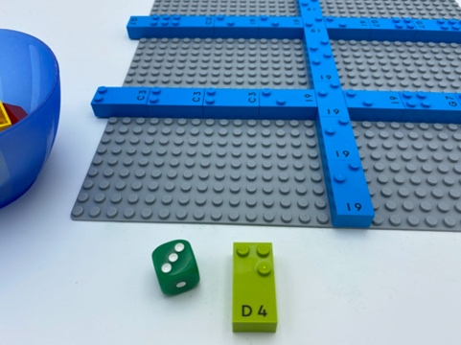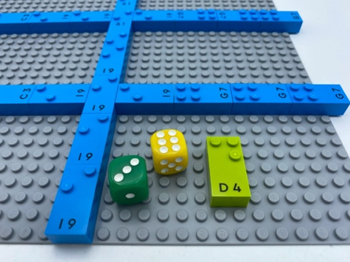

Let’s play
Players taking turns:
- Roll one die and read it. This number equals the number of passengers/studs to ride in your car.
- Find your car with the right number of passengers.
- Roll the other die and read it. This number equals the parking space number.
- Park your car in the corresponding space.
Game ends when the entire parking lot is full.

How to prepare
- 1 base plate
- All bricks
- 2 dice
Place bricks on the base plate to create a 6-car parking lot (2 columns of 3 spaces, like a braille cell).

Facilitation tips
- Preliminary exercise: introduce the concept of a parking lot being similar to a braille cell. Name aloud all the parking spaces.
- Build cars with 2 bricks allows easier tactile detection.

Possible variations
- Suggest players build the parking lot.
- Team play: player 1 roll die 1 and find the car, player 2 rolls die 2 and find the space.

Children will develop these holistic skills
- COGNITIVE - Relate numbers 1 through 6 with braille cell positions/dot number
- COGNITIVE – Use the number to show a rank, a position
- CREATIVE - Engage in imaginative play with others
- PHYSICAL - Use and produce representations of location
- SOCIAL - Follow rules in games led by adult, take turns

Did you know
- Social interaction is a powerful tool for both learning and play. By communicating their thoughts, understanding others through direct interaction and sharing ideas, children are not only able to enjoy being with others, but also to build deeper understanding and more powerful relationships.

