Feed a Caterpillar

10 min 1 participant

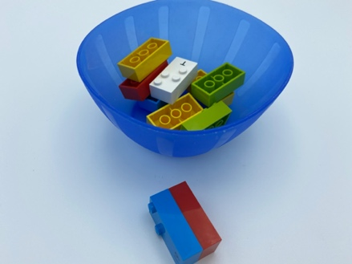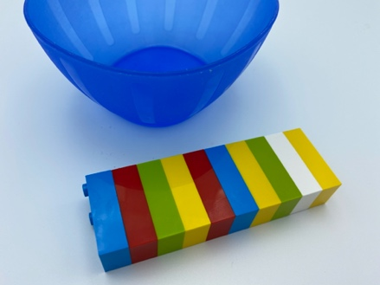

Let’s play
- Pick a caterpillar brick from the bowl.
- Feed the caterpillar by attaching another brick from the bowl, to make it grow!
- Keep the caterpillar growing by adding more bricks.

How to prepare
- 10 random bricks
- 1 bowl
Place the 10 bricks in the bowl.

Facilitation tips
- Demonstrate the connection of 2 bricks: the studs of one brick have to fit into the hollow part of another brick.
- Take 2 bricks, align them with fingers of both hands, fit them together, press.
- Provide an example of a caterpillar, if necessary.
- Allow the child to feel your fingers while you are building a caterpillar.
- Ask the child “How long do you think your caterpillar can be?”.

Possible variations
- Change the number of bricks.
- Peer play: taking turns, each child adds a brick to the caterpillar; each child makes their own animal.
- Together, they start making funny animals!

Children will develop these holistic skills
- COGNITIVE:
  - Recognize and use the notions of alignment, right angle, equality of lengths, middle, symmetry
  - Recognize spatial relationships: on, off, up, down, above, below, top, bottom, in front …
- PHYSICAL:
  - Develop motor skills and build body language: adapt motor skills to various situations, acquire specific techniques to improve efficiency
  - Develop bilateral hand use

Did you know
- This activity helps to develop self-regulation: learning how to evaluate and use necessary force to squeeze bricks together while keeping flexibility to align them.
- Learning through play happens when the activity is experienced as joyful, helps children find meaning in what they are doing or learning, involves active, engaged, minds-on thinking, as well as iterative thinking (experimentation, hypothesis testing, etc.), and social interaction.

