Cover the Bricks

5 min 1 participant

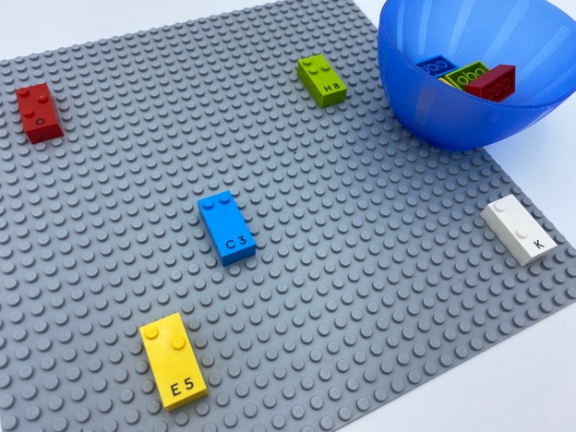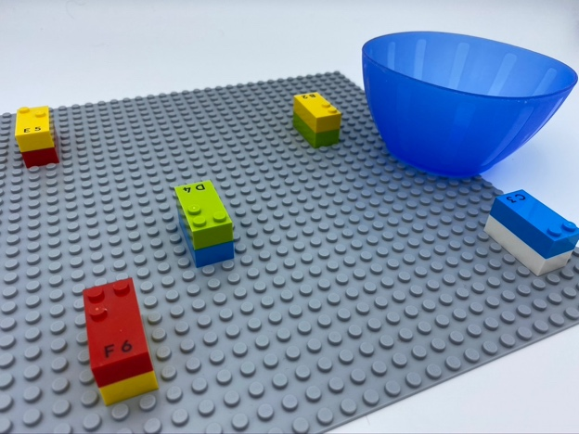

Let’s play
- Explore the base plate.
- Each time you find a brick on the base plate, place one of your bricks on top of it, to build a small tower.

How to prepare
- 1 base plate
- 10 random bricks
- 1 bowl
Place 5 bricks anywhere on the base plate, ensuring they do not touch each other.
Place the 5 other bricks in a bowl.

Facilitation tips
- Explain and show different spatial relationships like on top of, underneath… Explain by using the child’s hands (e.g. hide a brick under their hand, on top of it…).
- Encourage the child to use both hands.

Possible variations
- Suggest higher towers.
- Change number of starting bricks.
- Free play: add a LEGO mini figure to play with!

Children will develop these holistic skills
- PHYSICAL - Name spatial relationships
- EMOTIONAL - Control motor skills and emotional commitment to succeed in simple actions
- COGNITIVE - Recognize spatial relationships
- CREATIVE - Engage in solitary play activities for an appropriate amount of time
- SOCIAL - Plan and carry out routine or non-routine activities requiring multiple steps

Did you know
- Construction games are an excellent way to develop a strong mental representation of space.
- Learning is to go beyond memorizing academic content, by highlighting that children need to develop a breadth of skills. A holistic approach which also includes their physical, social, emotional, cognitive and creative skills is essential.

