Make a Masterpiece

30 min 1 participant

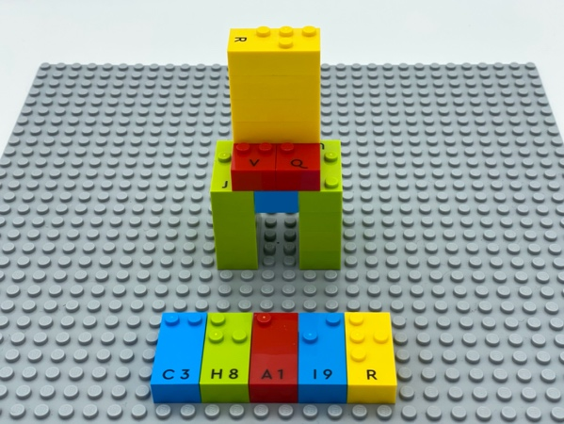

Let’s play
- Build a 3D masterpiece representing a fruit, an animal, a piece of furniture, a person…
- Write a word about the work of art on the base plate.

How to prepare
- 2 base plates
- All the bricks
Arrange several of each letter in alphabetical order on an additional storage base plate for ease in finding letters.
Other bricks will be used to build the construction.

Facilitation tips
- Colors of bricks can be relevant in masterpieces. Blind children understand that each brick is a specific color and can utilize them accordingly (green for leaves, yellow for the sun…
- When a child feels admiration and consideration of their art, it stimulates new ideas and techniques.
- Ask “Tell me a story about your artwork.”
- Ask “Why did you choose the word that you wrote?”.

Possible variations
- Propose an art project as Pablo Picasso.
- Write the title first and let the child build the masterpiece.

Children will develop these holistic skills
- COGNITIVE – Explain how to operate in a realistic situation: by stating a few key words describing action
- PHYSICAL - Engage in the activity over time and explore different possibilities, using manipulated objects: carry out increasingly complex assemblies
- EMOTIONAL - Develop an interest in art, works of art
- CREATIVE - Express self through craft, artwork: experiment with a variety of art media to create original artwork
- SOCIAL - Plan and carry out routine or non-routine activities requiring multiple steps

Did you know
- Children can practice spatial skills through playful activities, including block building, puzzle games and playing with materials of all kinds of shapes and sizes, and benefit from adults joining and supporting their play.

