Flower Picking

20 min 2 participants

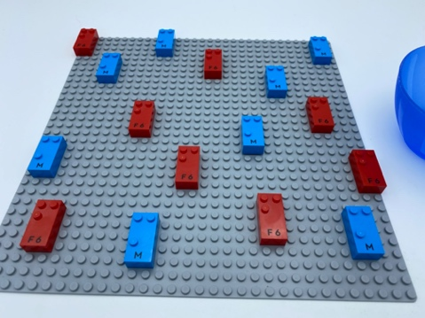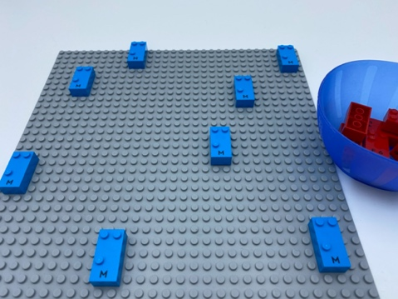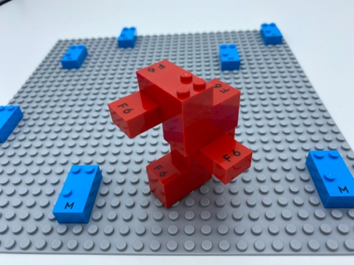

Let’s play
- Explore the flower and mushroom bricks growing in the field.
- Pick the flowers bricks (they include only dot 1, dot 2 and dot 4).
- Place them in the bowl.
- Make a bouquet with all the flowers.

How to prepare
- 1 base plate
- 16 letter bricks (8 "F", 8 "M")
- 1 bowl
Attach 16 vertical bricks (reading position) to the base plate in random locations.

Facilitation tips
- Preliminary exercises:
- Note the difference between an "F” and an "M" while repeating the dot’s names ("F" = dot 1, dot 2 and dot 4, "M" = dot 1, dot 3, and dot 4).
- Suggest recreation of the constellations, "F" and "M", in a braille cell egg carton.
- Ask “Who are these flowers for?”, “What is your favorite flower’s scent?”

Possible variations
- Change number of bricks
- Add other letters: "N" for nuts, "G" for grass…
- Change the ability to distinguish between the letters: i.e. A/Q (easily identified by touch), E/I (more difficult) …

Children will develop these holistic skills
- COGNITIVE – Use the number to show a rank, a position
- CREATIVE - Organize objects in play: engage in several familiar pretend-play sequences
- PHYSICAL - Develop tactile tracking skills: identify which word or letter is different/same
- EMOTIONAL - Implement an artistic project
- SOCIAL - Engage in game, pretend play activities, verbal play with peers

Did you know
- Facilitating children’s learning is different from thinking of teaching as “delivering content” because the goal is for the young child to understand concepts and develop a breadth of skills to be applied.

