Math symbols

20 min 1 participant

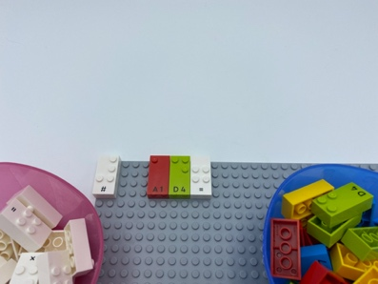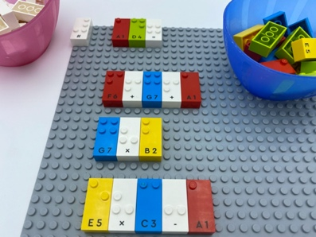

Let’s play
- Pick 2 bricks from the number brick bowl
- Write a 2-digit number
- Perform math operations with number and math sign bricks from the 2 bowl, to recreate the same 2-digit number.
- Place your operations on the base plate.

How to prepare
- 1 base plate
- Number bricks
- 1 number sign bricks
- Math sign bricks
- 2 bowls
Place the number sign brick on the top left corner of the base plate to indicate the bricks represent numbers.
Place number bricks and math signs bricks in 2 different bowls.

Facilitation tips
- Reminder: explanation of the importance of the number sign in front of each operation and that there are no spaces between the bricks.
- Encourage exploration of different operations to match the number. Several correct answers are possible.
- Ask “What was your strategy for solving the problem?”.

Possible variations
- Change the number of bricks to be picked.
- Peer collaboration: one player writes the operations and the other finds the correct answer.
- Propose challenge: multiple or specific math operations to equal a number.
- Find the math signs to be placed between the number bricks to equal a specific number.

Children will develop these holistic skills
- COGNITIVE - Practice scientific and technological approaches: formalize part of research in written or oral form
- COGNITIVE - Apply rules for braille contractions, punctuation and mathematical signs
- PHYSICAL - Learn through action, observation, analysis of personal and observed activity: learn by trial and error, cause and effects
- SOCIAL - Anticipate potential problems, identify steps for resolution including alternative solutions

Did you know
- What the students feel and think matters: they must get the feeling that they are part of their own learning and mastery of the content. Use open ended and guiding question techniques to support and encourage them.

