Hit the Target
Encourage and support base plate exploration and identification of number bricks to create and solve simple math equations.
10 min 2 participants

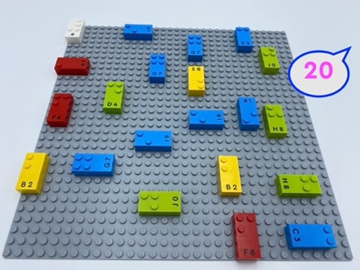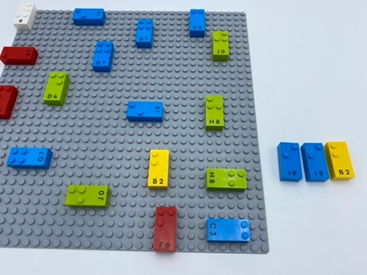

Let’s play
Player 1
- Say a number between 10 and 30; this is the target number!
Player 2
- Read the one-digit number bricks on the base plate
- Select and add number bricks, which added together equal the target number
- Place them in the bowl
Both Players
- Check the answer

How to prepare
- 1 base plate
- 20 number bricks from “0” to “9”
- 1 number sign brick
- 1 bowl
Place all the number bricks anywhere on the baseplate, in various positions (vertical, horizontal)

Facilitation tips
- Explain “Number sign brick placed once on the top left corner of the baseplate indicates all bricks are numbers.”
- Ask “What is your strategy to remember how the bricks are arranged on the base plate?”

Possible variations
- Change the number of bricks on the base plate, vary the target number possibilities
- Use 2-digit numbers on the baseplate
- Use other math operations to reach the target

- Children will develop these holistic skills
- COGNITIVE: Stabilize knowledge of small numbers: verbalize the decomposition of the number
- CREATIVE: Reproduce, assemble, organize, link graphic patterns and then create new ones
- EMOTIONAL: Share rules, roles and responsibilities
- SOCIAL: Plan and carry out routine or non-routine activities requiring multiple steps
- PHYSICAL: Locate objects by touch: Intentionally search for an object

Did you know
- Another surprise may be that numeracy is not only about numbers: it also relies on self-regulation or executive functions (EFs) and spatial skills.

