Cake Decorating

10 min 1 participant

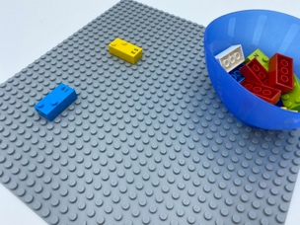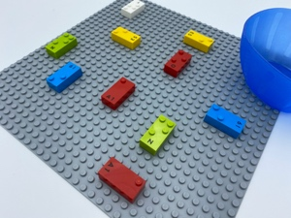

Let’s play
- Imagine the base plate is a giant cake and needs to be decorated.
- Imagine all the bricks are chocolate chips.
- Place all the bricks on the base plate, wherever you want but do not let them touch each other!

How to prepare
- 1 base plate
- 10 random bricks
- 1 bowl
Place the 10 bricks in the bowl.

Facilitation tips
- Cook a real cake and add decorations to it (send us a piece!).
- Ask the child to explore the base plate to make sure the bricks are placed all over the plate.
- Encourage bilateral hand exploration; coordination needs to be stimulated and developed for braille reading skills.

Possible variations
- Use a smaller base plate that can be held in one hand, if needed.
- Change the number of bricks.
- Perform the activity with peers.

Children will develop these holistic skills
- CREATIVE - Reproduce, assemble, organize, link graphic patterns and then create new ones
- PHYSICAL - Develop motor skills and build body language: acquire specific techniques to improve efficiency
- COGNITIVE - Explore a page
- EMOTIONAL - Comply with simple directions and limits from adults
- SOCIAL - Anticipate potential problems, identify steps for resolution including alternative solutions

Did you know
- Joy is at the heart of play - both enjoying a task for its own sake and the momentary thrill of surprise, insight, or success after overcoming challenges.

