Egg Carton Numbers

10 min 1 participant

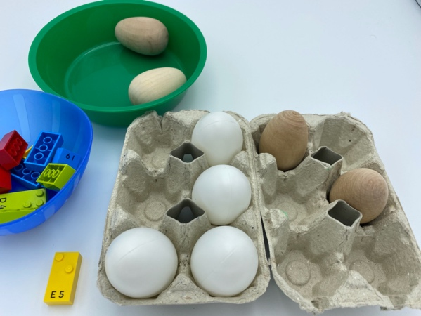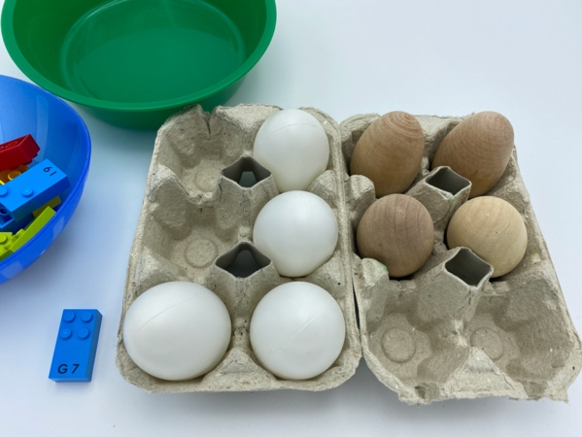

Let’s play
- Pick a number brick from the bowl.
- Read the number.
- Reproduce this number in the braille cell egg cartons. Don’t forget the first egg carton must be the number sign.

How to prepare
- 10 number bricks, from “0” to “9”
- 2 bowls
- 2 cartons for 6 eggs in portrait position, as a braille cell, e.g. 2 columns of 3 dots
- 8 plastic eggs or similar size objects
Place the bricks in one bowl and the eggs in the other.

Facilitation tips
- Provide explanation for the use of the first braille cell egg carton to indicate the number sign.
- Ask “Why must we place the number sign first?”

Possible variations
- Peer play: Player 1 performs the activity and replaces the number brick in the bowl. Player 2 reads the braille cell egg carton and finds the correct number brick in the bowl.
- Change the number of bricks.
- Use additional cartons and bricks for 2 or 3-digit numbers.
- Add non-number bricks.

Children will develop these holistic skills
- COGNITIVE - Explain process of doing, playing
- PHYSICAL - Engage in the activity over time and explore different possibilities, using manipulated objects: build a construction, copy from a reference manipulated or observe model
- PHYSICAL - Replicate a pattern of objects/shapes in a defined space
- EMOTIONAL - Control motor skills and emotional commitment to succeed in simple actions
- SOCIAL - Plan and carry out routine or non-routine activities requiring multiple steps

Did you know
- The key to the instructional practice is that learners are actively engaged. Educators can share their thoughts and decisions, guide exploratory discussions where children share and justify ideas, or encourage active participation through feedback.

