Find Upside Down

10 min 1 participant

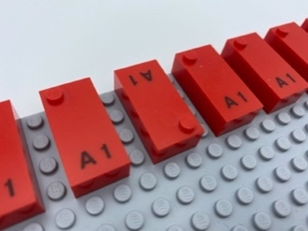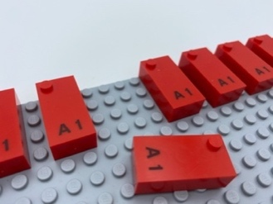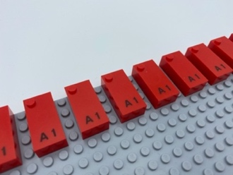

Let’s play
- Explore the base plate.
- Find the upside-down brick.
- Replace the brick right side up.

How to prepare
- 1 base plate
- 7 “A” bricks or more
Make a horizontal line of at least 7 “A” bricks, leaving a space between each of them.
Place all bricks, except one, in correct reading position.

Facilitation tips
- Explain that a character is always printed in the flat space on the bottom of each brick. Help the child identify this space on the brick. This is how you know the correct orientation of the brick.
- Ask the child to help you make this activity more fun/

Possible variations
- Start with only 3 bricks.
- Use other bricks, with more studs; start with the first series from “A” to “J”.
- Make several lines.
- Arrange bricks without spaces in between.
- Place more than one brick upside-down.
- Add a bowl with 7 letters “G”; ask the child to use the bricks in the bowl to make a line with one brick upside down.

Children will develop these holistic skills
- CREATIVE - Reproduce, assemble, organize, link graphic patterns and then create new one
      - PHYSICAL - Explore and investigate to get information about the tactual properties of an object
- SOCIAL - Anticipate potential problems, identify steps for resolution including alternative solutions
- COGNITIVE - Identify same/different braille shapes
- EMOTIONAL - Control motor skills and emotional commitment to succeed in simple actions

Did you know
- The braille alphabet is based on decades. The first one, from A to J, requires only the first 2 rows of dots on a braille cell: 1,2,4 and 5. This is the foundation upon which the other decades are built.
- Integrated teaching and learning approaches are combining child-directed learning, (making choices about the content and process of learning), teacher-guided learning (providing scaffolded learning at appropriate points), and teacher-directed learning (providing initial framing and explicit instructions when needed).

