Free the animals!

Explore and discriminate braille characters to save animals from captivity.

10 min 1 participant

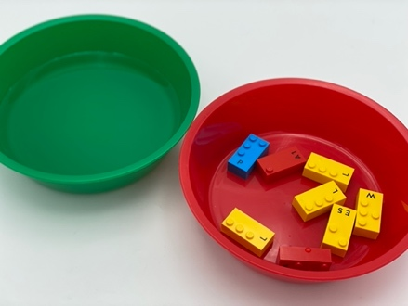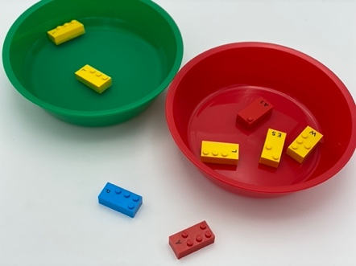

Let’s play
Each letter brick represents an animal.
L stands for Lobster, all other letters for birds: A for Albatross, E for Eagle, P for Parrot, W for Woodpecker, Y for Yellow canary.
- Pick a brick from the bowl
- If you have found a lobster, put it back into the water as quickly as possible!
- If you have found a bird, help it fly away!
- Continue until you have freed all the animals.

How to prepare
- 8 LEGO Braille Bricks (A, E, 3xL, P, W, Y)
- 2 containers (bowl, glass, cup…)
Place all the Braille Bricks in one container and fill the other with water.

Facilitation tips
- Ask “Tell me how birds can move?”, “Where does a lobster live?”
- Suggest “Think of a story about those animals, why are they together?”
- Ask “What is your strategy to free the animals as quickly as possible?”

Possible variations
- Change the number of bricks and variety of letters
- Vary the category of words: animals, fruits, vegetables…
- Add a timer
- Make it a collaborative activity

Children will develop these holistic skills
- CREATIVE: Organize objects in play: create and engage in creative dramatics and activities
- PHYSICAL: Explore and discriminate to get information about the tactual properties of an object
- SOCIAL: Cooperate and share: organize work in a group to develop a common task/collective production
- COGNITIVE: Identify the braille characters
- EMOTIONAL: Control motor skills and emotional commitment to succeed in simple actions

Did you know
The key to the instructional practice is that learners are actively engaged. Educators can share their thoughts and decisions, guide exploratory discussions where children share and justify ideas, or encourage active participation through feedback.

