Caterpillar to Butterfly

10 min 1 participant

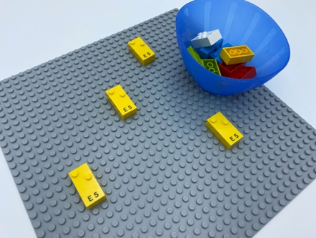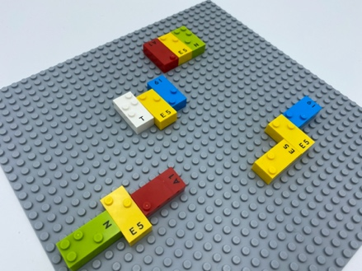

Let’s play
- Explore the base plate to find the 4 caterpillars.
- Help them turn into butterflies by adding 2 wings from the bowl: one on each side of their body.
- Imagine and tell the story of these caterpillars. What happened? What’s happening now?

How to prepare
- 1 base plate
- 12 random bricks
- 1 bowl
Attach 4 vertical bricks to the base plate in random locations, leaving enough space between them to add wings.

Facilitation tips
- The child might find several ways to place the wings: that’s great! Creativity must be encouraged.
- Ask the child to mimic a butterfly and move their wings.
- Encourage the child to express feelings and emotions with open-ended questions.

Possible variations
- Change the number of bricks.
- Add larger wings to make bigger butterflies.

Children will develop these holistic skills
- PHYSICAL - Develop motor skills and build body language
- CREATIVE - Use spoken language to develop understanding through speculating, hypothesizing, imagining and exploring ideas
- COGNITIVE - Recognize spatial relationships
- EMOTIONAL - Express many feelings and emotions in a manner appropriate to cause, setting, and severity of situation
- SOCIAL - Engage in game, pretend play activities, verbal play with peers

Did you know
- Tactile reading requires good exploration skills, so tactile exploration of a page should be encouraged and stimulated.
- Playful experiences offer a safe space for children to try out and take risks, where they fell a sense of agency and direct their own activities.

