Countdown

10 min 1 participant

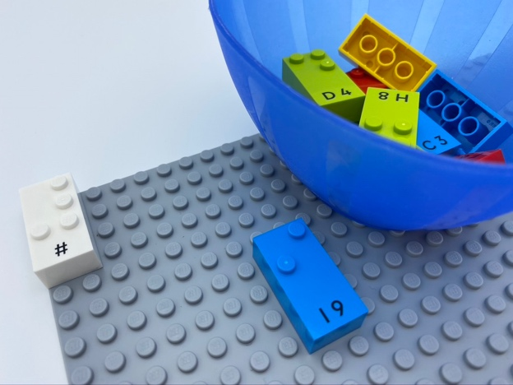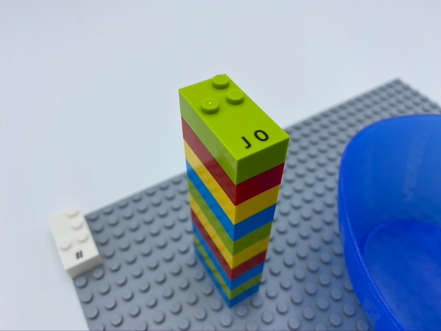

Let’s play
- Build a rocket with all the bricks starting with number “9”. Each brick has to represent a number lower than the previous one.

How to prepare
- 1 base plate
- 10 number bricks “0” to “9”
- 1 number sign brick
- 1 bowl
Place number sign in the top left corner of the base plate to indicate the bricks represent numbers.
Place the number bricks in the bowl.

Facilitation tips
- Explain what a countdown is.
- Create learning environments that empower young children to realize their potential: if the activity is linked to a story, the child will have a stronger motivation.
- Try to let the child build their own strategy and explain it.

Possible variations
- Pre-build the rocket with the first two bricks.
- Add more bricks than necessary.

Children will develop these holistic skills
- COGNITIVE
  - Count, read and write up to 10, forwards and backwards, beginning with 0 or 1
  - Stabilize knowledge of small numbers: given a number, identify one more and one less
  - Identify the braille characters: numerals 0 - 9
- CREATIVE - Engage in solitary play activities for an appropriate amount of time

Did you know
- Children need a deep, conceptual understanding of content knowledge together with skills that enable them to apply what they know.
- Cognitive skills mean concentration, problem solving, and flexible thinking by learning to tackle complex tasks and building effective strategies to identify solutions.

