Hula Hoops Constellation

30 min 3 participants

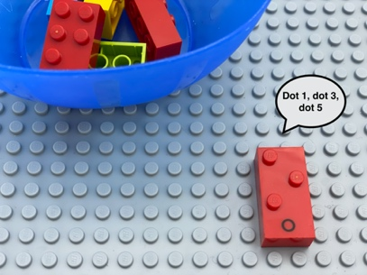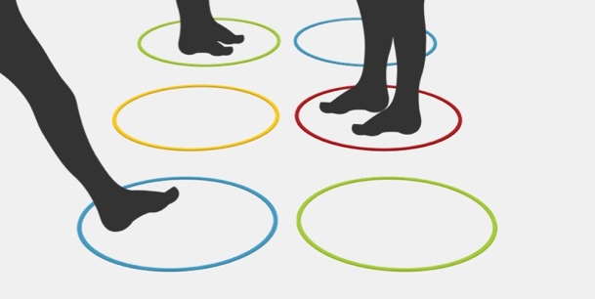

Let’s Play
- Player 1: pick a brick, feel the dots, say the dot’s numbers
(i.e. a “W” = dot 2, dot 4, dot 6).
- All children: work together to copy the constellation of dots by deciding who stands in which hoop and go to the right hoop, there may be more than one of you in a hoop.

How to prepare
- 6 Hula hoops
- 10 random bricks
Arrange the 6 hoops like a braille cell, and tape them on the floor.
Add a tactile marker on hoop number 1.

Facilitation tips
- Try some preliminary exercises:
- Walk in the “Hula Hoop braille cell” with child and tell where you are,
- Can you go into dot 5? Can you join me? I am in dot 2? Can you go from dot 1 to dot 6?
- Can you tell me in which dot I am standing in?
- Confusion between dot’s position in the braille cell, how we represent numbers in braille and the number of dots in the constellation can be avoided by saying “dot 2” and not only “2”.
- Choose 2 different kinds of hula hoops to make a distinction between the rows of dot 1-2-3 and dot 4-5-6.

Possible variations
- Choose a letter with more dots than the number of children who are playing (they will have to find a solution, like using an object, or asking the teacher to play…).
- Choose a letter with fewer dots (some children will need to stand in the same hoop) …
- Vary the types of markers for the dots (carpets…).

Children will develop these holistic skills
- PHYSICAL - Understand collective rules: achieve, through parallel actions, a common goal or effect
- EMOTIONAL - Control motor skills and emotional commitment to succeed in simple actions
- CREATIVE - Put into words procedures in peer-to-peer exchanges
- COGNITIVE - Relate numbers 1 through 6 with braille cell positions/dot number
- SOCIAL - Participate with other students in both leadership and follower roles

Did you know
- Active body engagement while learning helps to better integrate concepts, especially those related to space.
- Children are able to communicate ideas, collaborate with others, creatively innovate new solutions, critically think and evaluate data, have the confidence to try new things and be willing to fail, and, importantly, have the content knowledge as a foundation.

