Build a City!

Create and manipulate bricks to build a large city full of different types of structures and homes. Invite someone inside, for a guided tour.

15 min 1 participant

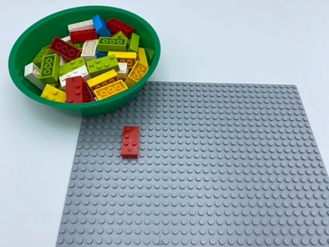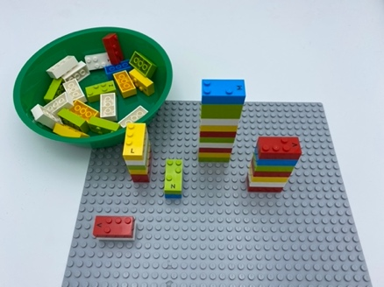

Let’s play
- Pick a brick from the box
- Attach it to the base plate
- Add other bricks, to build a large city out of LEGO Braille Bricks that can be seen from far, far away, and even from the sky!
- Give someone a guided tour of your city!

How to prepare
- 1 toolkit
- A base plate

Facilitation tips
- Ask player about where they grew up.
- Compare and discuss size and types of homes and buildings, urban space/country living
- Suggest building representation of hometown city or neighborhood
- Suggest adding minifigures to the city, for play!

Possible variations
- Build only a few buildings, a neighborhood
- Build a small village with only houses (one brick for one house)
- Use several bricks as foundations for the same building
- Add other base plates and play with peer to make a giant city!

Children will develop these holistic skills
PHYSICAL- Use and produce representations of solids and spatial situations
CREATIVE - Use spoken language to develop understanding through speculating, hypothesizing, imagining and exploring ideas.
COGNITIVE - Recognize and use notions of alignment, right angle, equality of lengths, middle, symmetry.
EMOTIONAL - Implement an artistic project.
SOCIAL - Anticipate potential problems, identify steps for resolution including alternative solutions.

Did you know
- Creative skills - coming up with ideas, expressing them and transforming them into reality by creating associations, symbolizing and representing ideas and providing meaningful experience for others.

