Find a Friend

10 min 1 participant

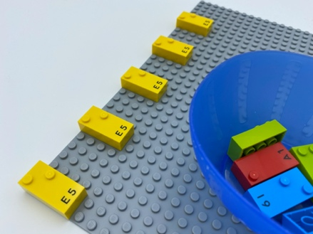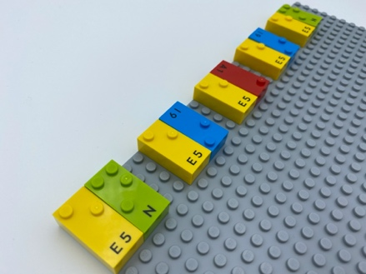

Let’s play
- Find the five lonely people on the base plate.
- Find them a friend from the bowl.
- Place a friend to the right side of each person.

How to prepare
- 1 base plate
- 10 random bricks
- 1 bowl
Make a horizontal line with 5 vertical bricks on the base plate. Start in the top left corner and leave 4 spaces between each of the bricks.
Place the 5 other bricks in a bowl.

Facilitation tips
- Differentiating the left side from the right side is aided by placing the first brick on the top left corner and asking to add a friend to that brick.
- Encourage bilateral hand exploration; coordination needs to be stimulated and developed for braille reading skills.
- Ask “How do you recognize right and left?”.
- Ask “Can you make this activity more fun?”.

Possible variations
- Change the number of bricks.
- Change the placement of the friend: i.e. below, on top of, fill the blanks…

Children will develop these holistic skills
- PHYSICAL - Discover the “spatial organization of a page”
- PHYSICAL – Locate objects by touch: intentionally search for an object
- CREATIVE – Reproduce, assemble, organize, link graphic patterns and then create new ones
- COGNITIVE - Recognize spatial relationships

Did you know
- For the blind child, the acquisition of laterality (learning left vs right) may be delayed. In order to learn braille, this concept must be understood, known and integrated by the child.
- Playful experiences in the early years promote acquisition of the critical learning skills needed throughout a lifetime.

