Bingo

30 min 3 participants

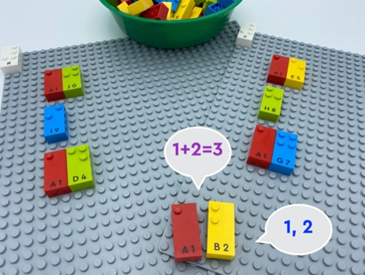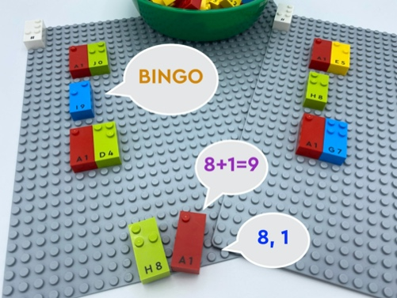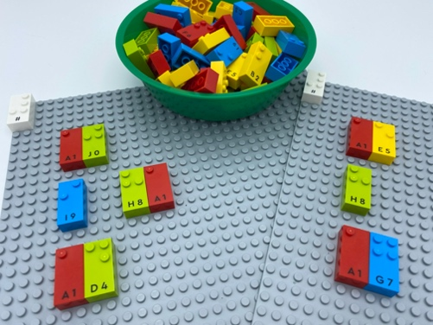

Let’s play
Bingo Caller
- Pick 2 bricks from the bowl.
- Read the 2 numbers aloud.
Other players
- Add the numbers together.
- Check your bingo card for the sum of the two numbers.
- Shout “Bingo!” if you have the number.
The first player who finds all 3 numbers wins!

How to prepare
- 2 base plates
- 2 number sign bricks
- All number bricks
- 1 bowl
Place the number sign brick on the top left corner of each base plate to indicate the bricks represent numbers.
Create a bingo card with a base plate for each player: write 3 numbers (from 1 to 17) on each one, ensuring there are no duplicate numbers.
Place the remaining bricks in the bowl.
Designate a player to be the “bingo caller”.

Facilitation tips
- The “bingo caller” has an important role: reminders to speak loudly and clearly so that all players can hear the correct numbers.
- Give everyone a chance to be the ”bingo caller”.

Possible variations
- Change the numbers of bricks picked from the bowl.
- Change the numbers of bricks on the base plate.
- Vary the type of math operation.
- Omit the math operation to search for single numbers.

Children will develop these holistic skills
- COGNITIVE - Explain process of doing, playing
- Identify the braille characters: numerals 0-9
- SOCIAL - Distinguish between personal and collective interests
- SOCIAL - Utilize a wide variety of nonverbal behaviors to improve communication
- EMOTIONAL - Identify socially acceptable and unacceptable behavior

Did you know
- Well-planned and intentional instruction with use of effective techniques can lead to improved academic outcomes and socio-emotional skills.

