Playdough Shapes

15 min 1 participant

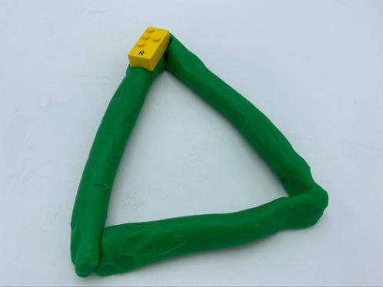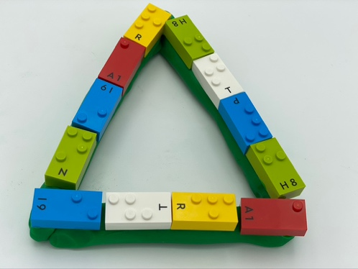

Let’s play
- Roll the playdough into a rope.
- Fold the rope to make a triangle.
- Align bricks on top of the playdough triangle.

How to prepare
- Random braille bricks
- Playdough

Facilitation tips
- Ask “What else looks like a triangle?”.
- Ask “What other shapes can you make?”.

Possible variations
- Change shape: circle, rectangle, hexagon…
- Make solid shapes, not just the contour and cover it with bricks.

Children will develop these holistic skills
- COGNITIVE – Recognize, classify and sort shapes in 2 dimensions
- CREATIVE - Spontaneously engage in free and then guided exploration of different tools and different media
- PHYSICAL - Develop bilateral hand use
- EMOTIONAL - Control motor skills and emotional commitment to succeed in simple actions
- SOCIAL - Plan and carry out routine or non-routine activities requiring multiple steps

Did you know
- Playdough allows the creation of more shapes with diagonal and curves.
- Playful experiences offer a safe space for children to try out and take risks, where they feel a sense of agency and direct their own activities.

