Up, Up, Down

10 min 1 participant

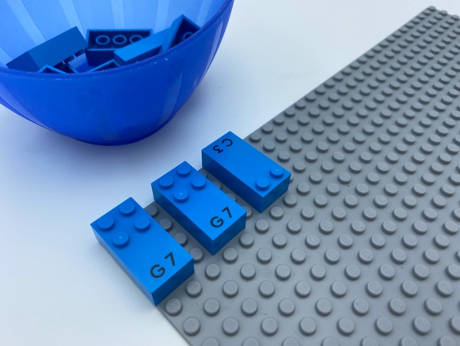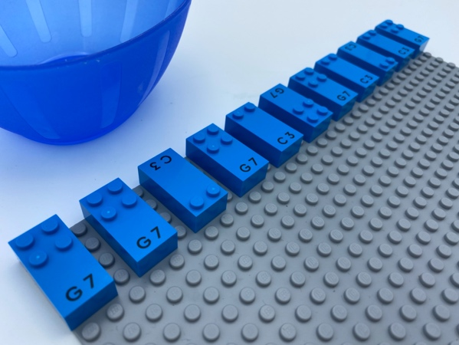

Let’s play
- Attach bricks from the bowl to make an “up, up, down” pattern in a line across the base plate: 2 bricks up (space at the bottom), 1 brick down (space at the top).
- Repeat the pattern until the end of the line.

How to prepare
- 1 base plate
- 11 letter bricks, a mix of “G” and “C”
- 1 bowl
Place the 11 bricks in the bowl.

Facilitation tips
- Explain that a character is always printed in the flat space on the bottom of each brick. Help the child identify this space on the brick. This is how you know the correct orientation of the brick.
- Change perspective: ask the child to find a new pattern for you to follow.

Possible variations
- Change the letter bricks.
- Change the pattern.
- Repeat the pattern in more lines.
- Create more patterns.

Children will develop these holistic skills
- COGNITIVE - Use numbers to show a rank, a position: build a suite identical to a proposed ordered suite
- CREATIVE - Reproduce, assemble, organize, link graphic patterns and then create new ones
- PHYSICAL - Organize: find objects; sort or categorize by placement, function, attribute
- EMOTIONAL - Understand rules
- SOCIAL - Anticipate potential problems, identify steps for resolution including alternative solutions

Did you know
- Children can practice spatial skills through playful activities, including block building, puzzle games and playing with materials of all kinds of shapes and sizes, and benefit from adults joining and supporting their play.

