Vowel and Consonant Towers

10 min 2 participants

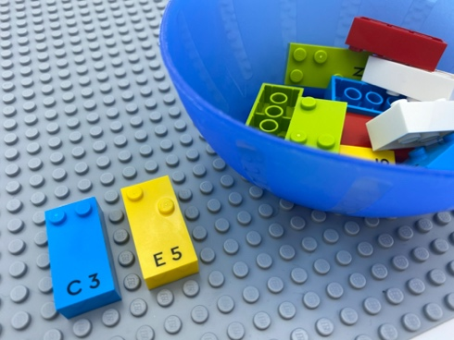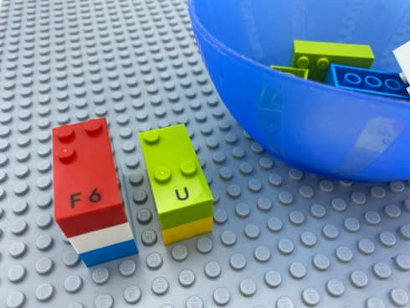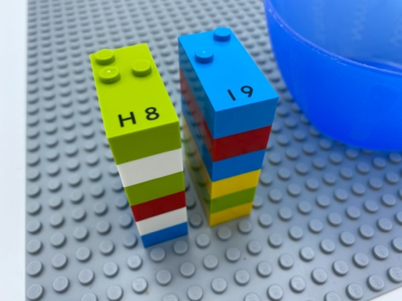

Let’s play
- Pick a brick.
- Read the letter.
- Identify if it is a vowel or a consonant.
- Build 2 towers: one composed of consonants, the other of vowels.

How to prepare
- 1 base plate
- 6 bricks with vowels and 6 with consonants
- 1 bowl
The 12 bricks are mixed in the bowl.

Facilitation tips
- Ask “How many do you think you got right?”.

Possible variations
- Align the bricks horizontally on the base plate (no bowl is needed).
- Choose different numbers of vowels and consonants.
- Use a timer.
- Increase the total number of bricks.
- Collaborate with peers to build the tallest tower using all bricks, just consonants, or vowels.

Children will develop these holistic skills
- COGNITIVE - Recognize words more and more easily: respond speedily with the correct sound to graphemes (letters or groups of letters)
- PHYSICAL - Read each letter, combine several letters together, produce a series of identical letters
- CREATIVE - Engage in solitary play activities for an appropriate amount of time
- SOCIAL - Follow rules in games led by adult, take turns

Did you know
- Academic outcomes, including literacy and numeracy, ultimately rely on many other skills across domains of children’s development.

