Braille Detective

Read, identify and correct errors in short sentences created in a peer play activity.

10 min 2 participants
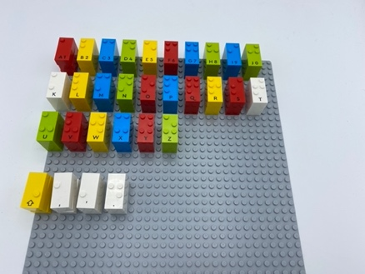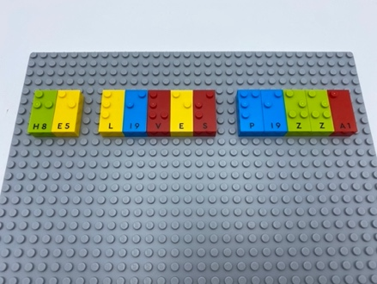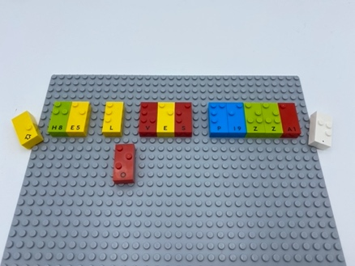
Let’s play
Player 1
- Write a short sentence with 3 mistakes
Player 2
- Read the sentence
- Look for mistakes and propose corrections
Both players
- Discuss corrections

How to prepare
- 2 base plates
- All the letter bricks

Prepare one of the base plates alphabetically for ease in finding letter bricks.

Facilitation tips
- Suggest “Use the alphabetical storage baseplate to quicky write your sentence”
- Ask “What is your strategy to read the words and correct mistakes?”

Possible variations
- Change the number of mistakes and the length of the sentence
- Replace sentences by words to be changed to plurals (eg. cat/cats, mouse/mice)
- Work on punctuation signs, upper case letters
- Place the few needed letters for correction in a bowl

- Children will develop these holistic skills
- COGNITIVE: Make suggestions for corrections to get closer to the written form (syntax, vocabulary, concordance of times)
- COGNITIVE: Apply rules for braille contractions, punctuation and mathematical signs
- CREATIVE: Perform operations on letters and word syllables: remove, add, reverse, locate, substitute
- EMOTIONAL: Discuss word meanings, link new meanings to those already known
- SOCIAL: Articulate and justify answers, arguments and opinions
- PHYSICAL: Develop tactile tracking skills: Sustain tracking along a line of braille.

Did you know
- Despite literacy being serious business, it can be learned in playful ways.
- When concepts are new or very complex to young children, high-quality instruction is especially important for their learning.

