Swing Cell

15 min 1 participant

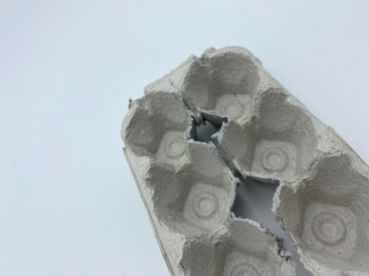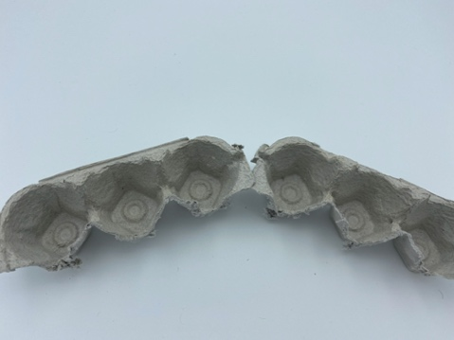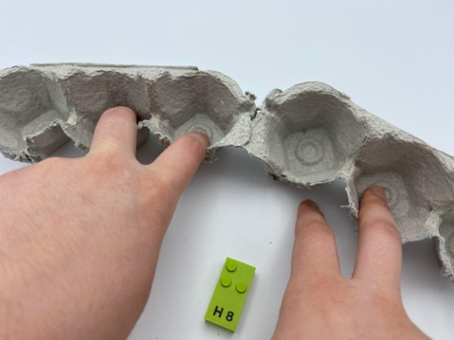

Let’s play
- Pick a brick from the bowl and read the dots on it.
- Reproduce the constellation of dots by placing your fingers in the egg box in "write braille position".

How to prepare
- 1 base plate
- 10 bricks from 1st decade "A" to "J"
- 1 bowl
- 1 braille cell egg carton
Without completely disconnecting the egg carton, cut it lengthwise in 2 lines of 3 compartments, being certain the 2 rows stay connected at one end to use it as a swing cell.
When the swing cell is extended it demonstrates the writing braille position (dots are numbered left to right 3, 2, 1, 4, 5, 6).
Place the 10 bricks in the bowl.

Facilitation tips
- Preliminary exercise:
  - Manipulate the egg carton as a "swing-cell" and go from "reading braille position" to "writing braille position".
  - Repeat the activity with all 6 fingers in the corresponding compartments: left index finger=dot 1, left middle finger=dot 2, left ring finger=dot 3, right index finger=dot 4, right middle finger=dot 5 and right ring finger=dot 6.

Possible variations
- Change bricks: use letter bricks from other decades, with dot 3 and dot 6.

Children will develop these holistic skills
- COGNITIVE - Relate dot numbers 1 through 6 with finger and braille key positions to write in braille with a braille typewriter or computer
- CREATIVE - Reproduce, assemble, organize, link graphic patterns and then create new ones
- PHYSICAL - Develop finger isolation: single finger use
- EMOTIONAL - Solicit information/assistance from appropriate persons in various settings
- SOCIAL - Understand, respect and enforce rules and regulations

Did you know
- The egg carton is an excellent tool: it is a giant braille cell! Children will learn the 6 dot positions and then braille characters.
- The braille alphabet is based on decades (series). The first one, from A to J, requires only the first 2 rows of dots on a braille cell: 1, 2, 4 and 5. This is the foundation upon which the other decades are built.

