What Letter is Missing?

20 min 2 participants

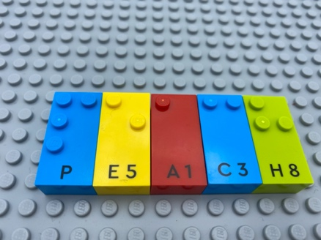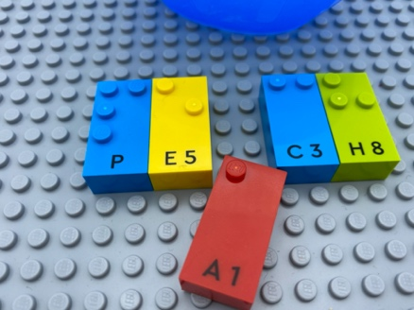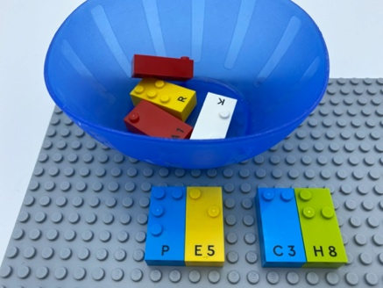

Let’s play
Player 1
- Think of a word and find the letters to write the word on the base plate.
- Remove a letter and place it in the bowl with 3 other letters you choose.
Player 2
- Read the letters and decide which letter is missing.
- Find the missing letter in the bowl and fill in the word.
- Read the word.

How to prepare
- 1 base plate
- Letter bricks
- 1 bowl

Facilitation tips
- Ask “What was your strategy for the activity?”.
- Ask “What happens if your words are not the same?”.
- Additional letters can be pre-arranged in alphabetical order on an additional base plate. Could be a warm-up activity!

Possible variations
- Change the number of bricks in the bowl.
- Change the number of letters removed.
- Change word length.

Children will develop these holistic skills
- COGNITIVE - Discover the function of the written word: identify letters and their order; and then, depending on the letter, its sound value
- EMOTIONAL - Develop vocabulary and understanding in reading: discuss word meanings, link new meanings to those already known
- CREATIVE - Utilize adapted games/materials during free time
- PHYSICAL – Develop tactile tracking skills: locate, read an identified number of word or letter on a line
- SOCIAL - Request and accept help from others, use peers as a resource

Did you know
- Children need high-quality interactions with peers and adults for this learning to take place.

