Be the Cook

Create a favorite sandwich and transform letters into delicious treats.

10 min 1 participant

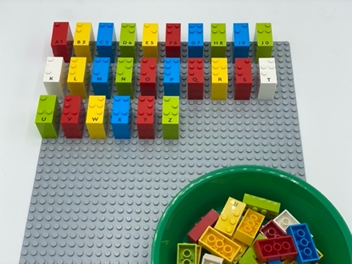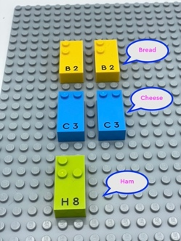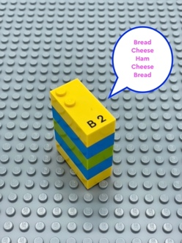

Let’s play
Each letter brick represents an ingredient
- Think of a sandwich you want to eat.
- Search the alphabetical base plate for the first letters of each ingredient in your sandwich
- Build your sandwich on your base plate

How to prepare
- 2 base plates
- All letter bricks

Prepare one of the base plates alphabetically for ease in finding letter bricks.

Facilitation tips
- Suggest “Imagine you are ordering your favorite sandwich in a fun restaurant”
- Ask “How did you stack your sandwich? In a pile? Flat on the baseplate?”
- Offer sandwich ideas “s’mores: “G” for graham, “C” for chocolate, “M” for marshmallow”

Possible variations
- Use letter bricks to represent a story: “L” for lake, “T” for trees, “H” for house…
- Determine bricks are food items at the supermarket or clothes in a chest of drawers.

- Children will develop these holistic skills
- COGNITIVE: Tell, express, analyze: explain how to operate in a realistic situation: by stating a few key words describing action
- CREATIVE: Retell or create simple stories
- EMOTIONAL: Discuss personal likes and dislikes
- SOCIAL: Engage in game, pretend play activities, verbal play with peers
- PHYSICAL: Learn to preplan actions

Did you know
- Children learn more when they are actively engaged as opposed to passive, when activities are meaningful to them and when they learn together with others.
- When playing in an imaginary store, children use mathematical abilities and oral language skills.

