Missing Letters

10 min 1 participant

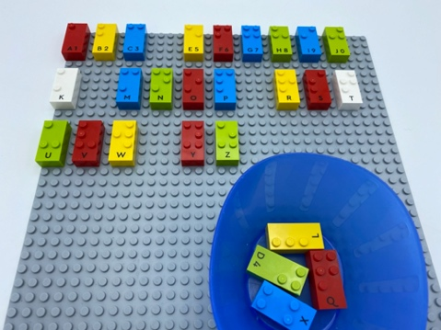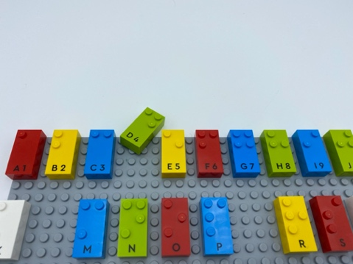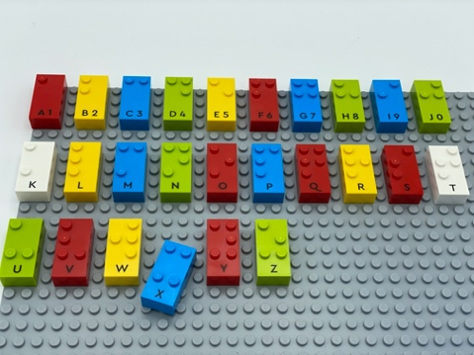

Let’s play
- Track the lines on the base plate with your index fingers.
- Read the letters.
- Pick and place the correct bricks from the bowl to complete the alphabet.

How to prepare
- 1 base plate
- 26 letter bricks, from “A” to “Z”
- 1 bowl
Arrange the bricks in alphabetical order on the base plate, leaving an empty space between each letter.
Remove 1 or more bricks and place them in the bowl.

Facilitation tips
- Ask “How can you be sure you completed the alphabet correctly?”.
- Ask “What was your strategy for identifying the missing letters?”.

Possible variations
- Change the number of missing letters.
- Add extra bricks to the bowl.
- Place letters incorrectly on the base plate.

Children will develop these holistic skills
- COGNITIVE – Spell further homophones, words that are often misspelt, words containing various phonemes, common exception words, the days of the week, the letters of the alphabet
- COGNITIVE - Use hands and fingers in braille reading: use two hands to track braille, from left to right
- CREATIVE - Describe an organization produced or observed
- PHYSICAL - Name logical relationships
- EMOTIONAL - Solicit information/assistance from appropriate persons in various settings

Did you know
- Engaged learners demonstrate motivation and commitment towards their learning, often extending themselves beyond set goals and expectations.

