Magic rectangles

15 min 1 participant

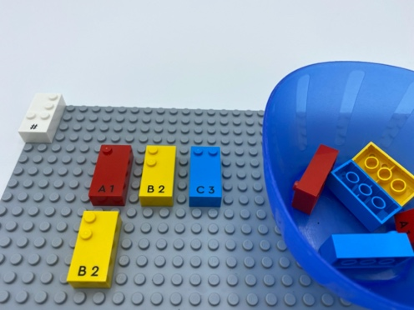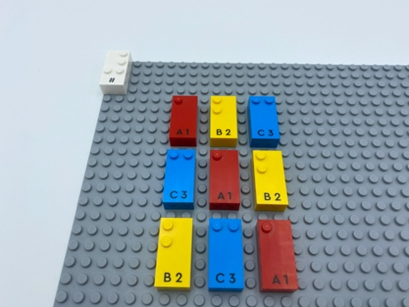

Let’s play
- Build a rectangle on the base plate with 3 rows that include 3 bricks in each row.
- Make it a magic rectangle by rearranging the bricks until each row and column of bricks added together equals the magic number 6.

How to prepare
- 1 base plate
- 9 number bricks (3 of each of the numbers “1”, “2” and “3”)
- 1 number sign brick
- 1 bowl
Place the number sign brick on the top left corner of the base plate to indicate that the bricks represent numbers.
Place the other bricks in the bowl.

Facilitation tips
- Suggest extra space between bricks for easier manipulation.
- Demonstrate and explain examples of a non-magic and a magic rectangle.
- Ask “What make this is a magic rectangle?”.
- Ask “What was your strategy for completing the activity?”.

Possible variations
- Create a magic rectangle with 2 missing bricks.
- Change composition of magic rectangles with the same 9 bricks.
- Create a magic rectangle with number bricks “1” to “9”.
- Construct a rectangle with number bricks “1” to “16” to create a 4 x 4 shape -magic number equals 34.

Children will develop these holistic skills
- COGNITIVE - Solve problems that require the organization of multiple data or the construction of an approach that combines reasoning steps (addition and subtraction…)
- COGNITIVE - Explain process of doing, playing
- PHYSICAL - Recognize real situations that can be modeled by geometric relationships (alignment, parallelism, perpendicularity, symmetry)
- PHYSICAL - Use both hands to track across broken lines on a page and identify space between lines
- SOCIAL - Plan and carry out routine or non-routine activities requiring multiple steps

Did you know
- Numeracy is not only about numbers: it also relies on self-regulation or executive functions and spatial skills.

