Pick a Letter and Pronounce

15 min 1 participant

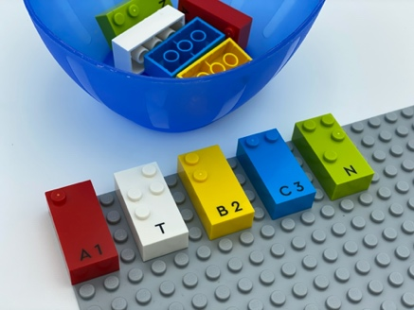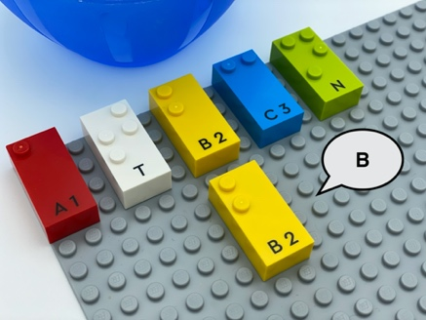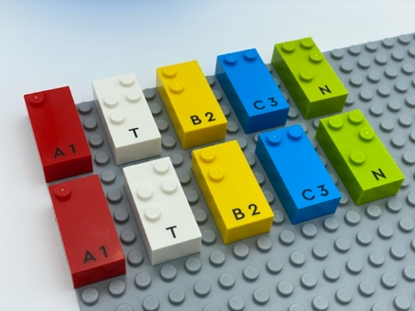

Let’s play
- Read the letters on the base plate with both hands.
- Pick a letter from the bowl.
- Speak its sound.
- Find the same letter on the base plate.
- Place the two identical bricks together.

How to prepare
- 1 base plate
- 2 identical sets of 5 letters each
- 1 bowl
One set is in the bowl and the other is horizontally aligned on the base plate.

Facilitation tips
- Suggest “Imagine a story using the sounds of the letters”.
- It can be tougher to find the bricks arranged in a column, rather than in a line: different tactile skills are used!

Possible variations
- Choose letters with a close sound.
- Increase the number of letters.
- Put one or more extra brick(s) in the bowl so the child has to ignore some bricks.
- Place letters in line, in column or randomly.
- Increase the number of players: each player has a base plate with the same letters and the bowl is in the center.

Children will develop these holistic skills
- COGNITIVE - Identify letters and their order and then, depending on the letter, its sound values CREATIVE - Make the sound of a letter and count the phonic syllables of a word
Explore vocal sounds
- EMOTIONAL - Solicit information/assistance from appropriate persons in various settings

Did you know
- Creative skills are used when coming up with ideas, expressing them and transforming them into reality by creating associations, symbolizing and representing ideas and providing meaningful experience for others.

