Let’s Play Categories!

Develop vocabulary through a well-known game, by finding and giving lists of foods, countries, animals....

30 min 2 participants

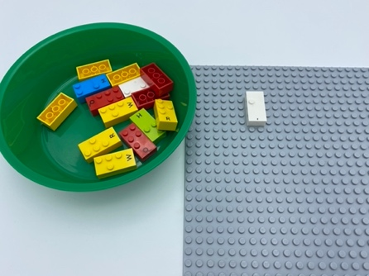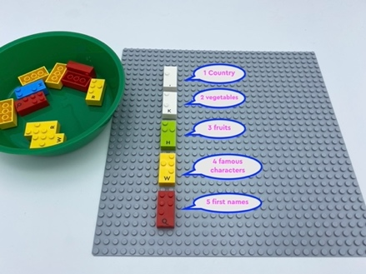

Let’s play
Players taking turns
- Pick a brick from the box
- Count the number of dots on it
- The number of dots indicates the category:
  - 1 dot: countries
  - 2 dots: vegetables
  - 3 dots: fruits
  - 4 dots: animals
  - 5 dots: famous characters
  - 6 dots (if you have 6-dot bricks in your set): first names
- Name 3 things in your category

How to prepare
- All bricks

Facilitation tips
- Discuss with the child, collaborate to choose categories.
- Repeat the list of categories as needed.

Possible variations
- Change the categories, depending on child’s knowledge
- Change the number of things to name
- Play with more peers

Children will develop these holistic skills
COGNITIVE - Stabilize knowledge of small numbers: Count quantities up to ten
EMOTIONAL - Share rules, roles and responsibilities
CREATIVE - Put into words procedures in peer-to-peer exchanges
PHYSICAL - Recognize and discriminate SHAPES by touch
SOCIAL - Engage in game, pretend play activities, verbal play with peers

Did you know
- Well-designed games can lead to literacy and numeracy skills.
- Despite literacy being serious business, it can be learned in playful ways.

