Save the Turtles!

5 min 1 participant

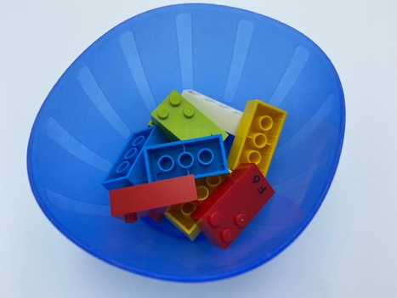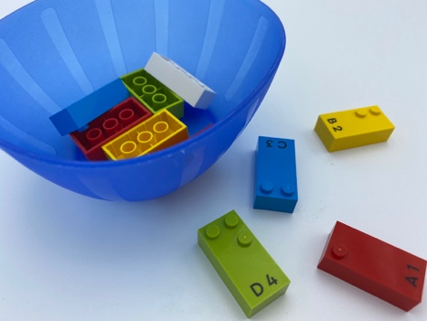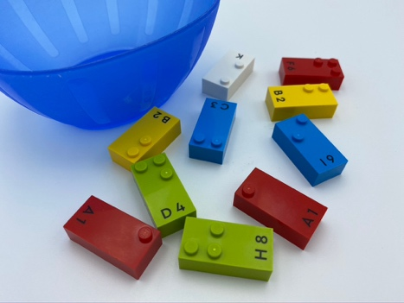

Let’s play
- Help the turtles get back on their feet! (the side of the bricks with the studs on is their shell).
- Choose a turtle.
- Find the turtle’s shell with the studs.
- Place the turtle on the table, with the studs facing up.
- Let’s play with your turtles!

How to prepare
- 10 random bricks
- 1 bowl
Place the 10 bricks in the bowl.

Facilitation tips
- Ask child to feel the difference between the top (with studs) and the bottom (with holes) of the brick and explain how they are different.
- Instruct the child to leave their index finger on the studs, to identify location, while placing the brick on the table.

Possible variations
- Replace LEGO Braille bricks with DUPLO - studs and holes are larger and easier to feel.
- Replace LEGO Braille bricks with regular LEGO - more studs to feel.

Children will develop these holistic skills
- PHYSICAL - Name spatial relationships: use spatial phrases, especially those based on oppositions: on/under, in/out, next to/far from…
- PHYSICAL - Explore and investigate to get information about the tactual properties of an object (by moving hands or by moving the object)
- EMOTIONAL - Control motor skills and emotional commitment to succeed in simple actions
- COGNITIVE – Recognize, classify and sort shapes in 2 dimensions

Did you know
- Studies show that a raised element is more easily detected than one which is recessed.
- Spatial skills allow us to imagine, rotate, manipulate and navigate objects within our minds.
- Activities are meaningful, when they integrate learner’s experiences and knowledge from home and school. This gives a voice to learner’s experiences and backgrounds and makes learning meaningful and culturally relevant to them.

