Battle

20 min 2 participants

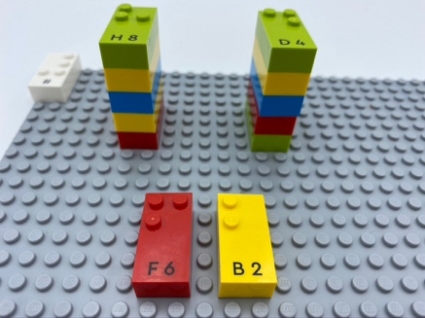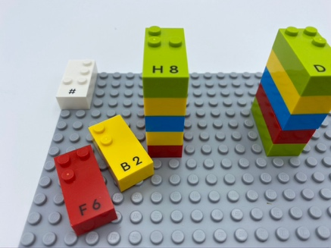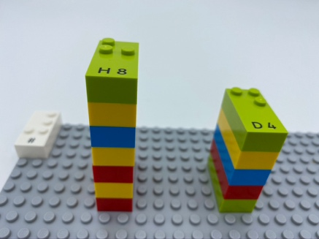

Let’s play
Both players
- Build a tower with your bricks on the base plate.
- Remove your top brick and play it on the base plate.
- Read and compare your numbers.
- Take both bricks if your number is the highest and build your tower higher by adding them underneath.
- If your 2 bricks are identical, take the next brick from your tower and compare again.
- Take all 4 bricks if you win.
- Repeat activity until one player has all the bricks.

How to prepare
- 1 base plate
- 12 number bricks
- 1 number sign brick
Place the number sign brick in the top left corner of the base plate.
Give each player 6 randomly selected bricks.

Facilitation tips
- Explain that we are not going to put the number sign in front of each brick. The number sign in the top left corner of the base plate indicates that all the bricks are numbers
- Ask “How do you know a number is higher than another one?”

Possible variations
- Change the rules: lowest number wins, even number wins…
- Use this activity to learn multiplication tables: the 2 bricks have to be multiplied. The quickest to give the correct answer wins.

Children will develop these holistic skills
- COGNITIVE - Construct the number to express quantities
- SOCIAL - Cooperate and share: work together to facilitate individual learning
- CREATIVE - Identify various leisure activities to be done alone or with other people
- EMOTIONAL - Follow courteous behavior: use conventional courtesy, identify socially acceptable and unacceptable behavior

Did you know
- Activities are socially interactive, when they involve learners working together in groups, using strategies that have been designed to maximize the benefit of cooperative learning. These opportunities can dissolve barriers between individuals and group and foster learner’s interpersonal, communication and social skills.

