Hidden Word

20 min 2 participants

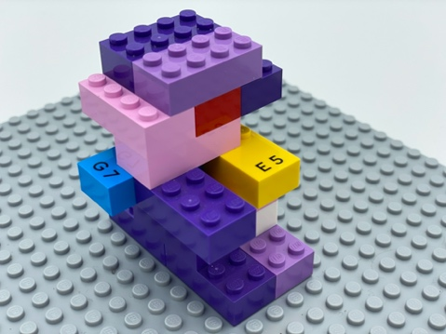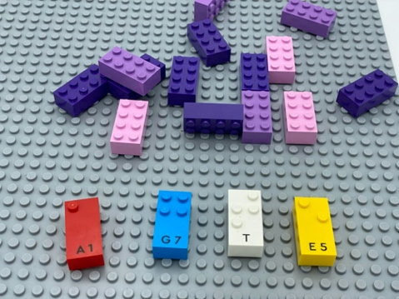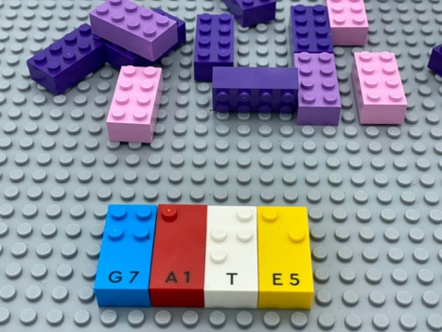

Let’s play
Player 1
- Think of a 3 or 4 letter word.
- Find the letter bricks you need to spell it.
- Hide the bricks for your word by building a construction made of standard 2x4 LEGO bricks and the Braille Bricks.
Player 2
- Find the hidden Braille Bricks inside the construction.
- Write a word with all the letter bricks found.
Both players
- Compare and discuss the words created.

How to prepare
- 1 base plate
- Letter bricks
- Classic 2x4 LEGO bricks
- 2 bowls
Place the letter bricks in one big bowl and the classic bricks in the other.

Facilitation tips
- Arrange several of each letter in alphabetical order on an additional storage base plate for ease in finding letters. This can be prepared in advance or a warm-up activity for the child.
- Suggest “Imagine a story in which your word is the highlight of the adventure”.

Possible variations
- Hide additional words.
- Change the number of letters in the word.
- Build construction to relate to the hidden word.

Children will develop these holistic skills
- COGNITIVE - Enrich the lexicon, acquire grammatical and lexical spelling
- CREATIVE - Adapt a project according to constraints and audience
- EMOTIONAL - Develop vocabulary and understanding in reading: discuss word meanings, link new meanings to those already known
- PHYSICAL - Manipulate, make an intentional movement with an object
- SOCIAL - Plan and carry out routine or non-routine activities requiring multiple steps

Did you know
- Recent research shows how curiosity and positive experiences are linked to learning.

