Gold Nugget

Searching and digging for gold, to find and manipulate LEGO bricks, in a treasure hunting activity.

10 min 1 participant

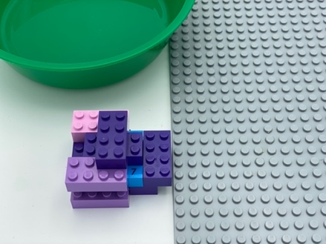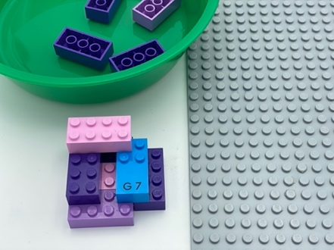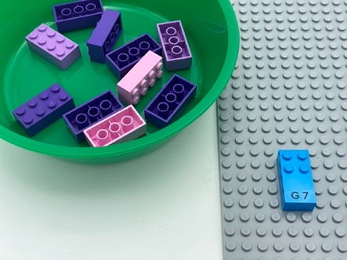

Let’s play

- Remove the bricks one by one to find the LEGO Braille Bricks inside this rock: it is a Gold Nugget
- Place the bricks that are not the Gold Nugget in the bowl
- Attach your Gold Nugget to the base plate

How to prepare
- 1 base plate
- 10 classic 2x4 LEGO bricks
- 1 letter brick “G”
- 1 bowl
Build a construction around the letter brick “G”, using the 10 classic 2x4 LEGO bricks.

Facilitation tips
- Allow choice of treasure to be found, according to the child's interests

Possible variations
- Change the letter brick to coincide with chosen treasure
- Change the number/shape of LEGO bricks
- Increase the number of Gold Nuggets
- Increase the number of rocks

Children will develop these holistic skills

COGNITIVE - Recognize, classify and sort shapes in 2 dimensions
CREATIVE - Describe an organization produced or observed
PHYSICAL - Compare - discover similarities, differences, and preferences: sort and match
EMOTIONAL - Control motor skills and emotional commitment to succeed in simple actions
SOCIAL - Plan and carry out routine or non-routine activities requiring multiple steps

Did you know
- Children can learn to carry out multi-step activities, resist distractions and choose tasks suited to their interests and skill level, just as they can learn to use more advanced problem-solving strategies.

