Market Shopping
Increase vocabulary and organize letters to create and write words. Develop and encourage creation of personal memory skills.
15 min 2 participants
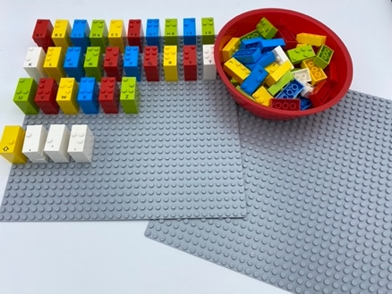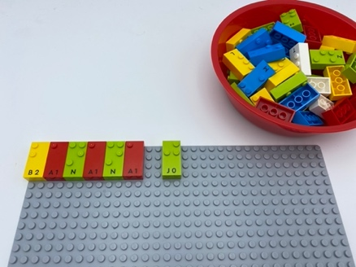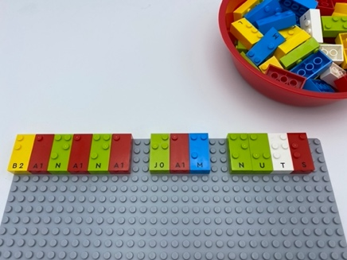

Let’s play
Player 1
- Pick a letter
- Place it at or near the top left corner of the shared baseplate
- Think of a word of something to buy at the market starting with this letter. Find the letters you need and complete the rest of the word.
- Say the whole sentence “I went to the market and bought …(say your word)”
Player 2
- Repeat actions 1 thru 3
- Say the whole sentence “I went to the market and bought …(repeat market items previously named and add your new purchase)”

How to prepare
- 2 base plates
- All the letter bricks

Prepare one of the base plates alphabetically for ease in writing words.

Facilitation tips
- Suggest “How can you remember all the words without reading them?”
- Propose “Tell a story using all the new words”
- Encourage collaborative help between players.

Possible variations
- Propose a specific topic for new words (fruits, school items, kitchen objects)
- All words must start with the same letter
- Don’t complete the words on the base plate

Children will develop these holistic skills
- COGNITIVE: Participate in the writing of certain words
- CREATIVE: Write as a leisure activity
- EMOTIONAL: Develop vocabulary and understanding in reading
- SOCIAL: Articulate and justify answers, arguments and opinions
- PHYSICAL: Improve listening comprehension skills: Understand vocabulary

Did you know
- Despite literacy being serious business, it can be learned in playful ways.
- When concepts are new or very complex to young children, high-quality instruction is especially important for their learning.

