Remove

5 min 1 participant

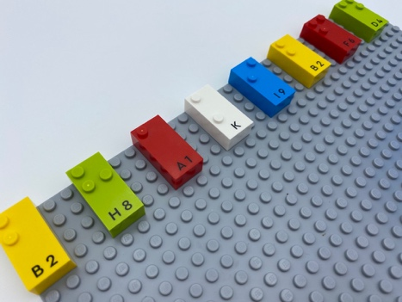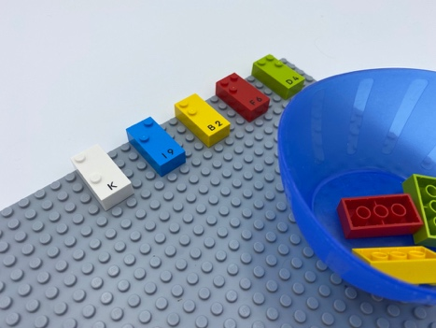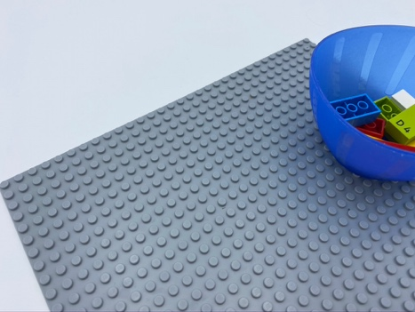

Let’s play
- Explore the base plate.
- Remove the bricks from the base plate and place them in the bowl.

How to prepare
- 1 base plate
- 8 random bricks
Place the 8 vertical bricks in a horizontal line, on the base plate, beginning in the top left corner. Leave 2 spaces between each brick.

Facilitation tips
- Ask “How can we make this activity more fun?”.
- Ask “Can you explain to me how you managed to remove the bricks?”.
- Ask “How can you be sure there are no more bricks left?”.

Possible variations
- Change the size of base plate.
- Place the bricks randomly all over the base plate.
- Change the number of bricks.
- Remove the first brick with the right hand, the second with the left hand…

Children will develop these holistic skills
- CREATIVE - Spontaneously engage in free and then guided exploration of different tools and different media
- PHYSICAL - Discover the “spatial organization of a page”
      - Take reference points in the page
      - Find way around a page (go from left to right and maintain alignment)
      - Use the appropriate vocabulary: top and bottom, left and right…
- Develop grasp and release
  - EMOTIONAL - Understand rules

Did you know
- Getting into the habit of exploring the base plate from left to right, and from top to bottom, facilitates the acquisition of reading and writing directions.
- For young children to progress, early learning practices need to meet them where they are and challenge them to go further.

