Twin Sculpture

Develop tactile exploration technique and location of bricks, to recreate an identical flat sculpture

15 min 1 participant

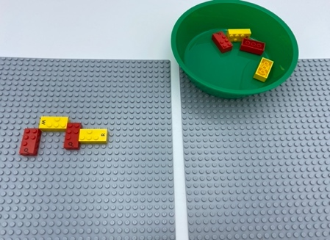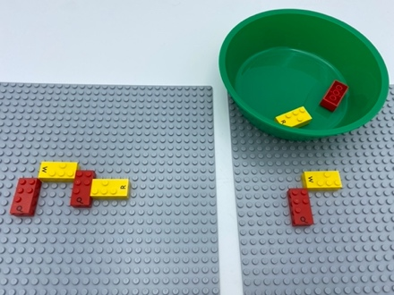

Let’s play
- Find the sculpture created on one of the base plates
- Take your time to explore it
- Make a twin sculpture on the other base plate.

How to prepare
- 8 equal sign bricks (“=”)
- 2 base plates
- 1 bowl
Create a flat 4-brick sculpture on one base plate.
Place the other 4 bricks in a bowl.

Facilitation tips
- Allow adequate time for trial and error method to create proper reproduction on the base plate.
- Suggest removal and relocation of sculpture, if it doesn’t fit on the base plate.

Possible variations
- Change the number of bricks, or sculptures.
- Create 3D sculptures.
- Peer play: one player creates, the other, reproduces the sculpture.

Children will develop these holistic skills
- COGNITIVE – Tell, express, analyse: explain process of doing, playing
- EMOTIONAL- Know the purpose of an activity
- CREATIVE – Reproduce, assemble, organize, link graphic patterns and then create new ones
- PHYSICAL - Recognize and discriminate shapes by touch
- SOCIAL – Plan and carry out routine or non-routine. Activities requiring multiple steps

Did you know
- Children can learn to carry out multi-step activities, resist distractions and choose tasks suited to their interests and skill level, just as they can learn to use more advanced problem-solving strategies

