Word Scramble

20 min 2 participants

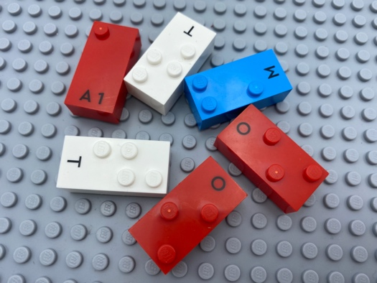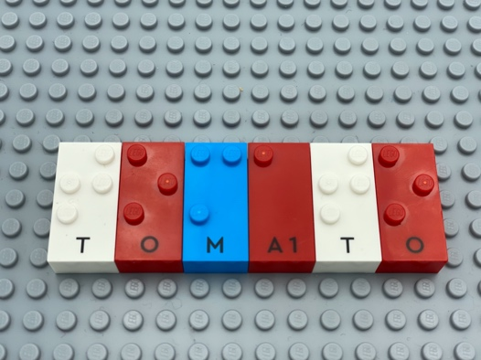

Let’s play
Player 1
- Think of a word and find the letters for your word.
- Mix them up in your hand and give them to player 2.
Player 2
- Read the letters.
- Make a word using all the letters.
- Write word on your base plate.
Both players
- Compare and discuss your words.

How to prepare
- 1 base plate
- All the letter bricks
Place the bricks and the base plate between the players.

Facilitation tips
- Clues about the word may be helpful: definition, placement of letters …
- “Imagine a story about your word. Think of other words for your story”
- Additional letters can be pre-arranged in alphabetical order on an additional base plate. Could be a warm-up activity!

Possible variations
- Designate a specific number of or mandatory letters to be used.
- Change the number of players.

Children will develop these holistic skills
- CREATIVE - Perform operations on letters and word syllables: remove, add, reverse, locate, substitute
- SOCIAL - Participate in discussions, presentations, performances, role play, improvisations and debates: gradually use appropriate vocabulary and/or ratings to describe a situation, present an argument
- COGNITIVE - Locate name in braille
- EMOTIONAL - Solicit information/assistance from appropriate persons in various settings

Did you know
- Children learn more when they are actively engaged as opposed to passive, when activities are meaningful to them and when they learn together with others.

