Body Braille Twister

20 min 1 participant

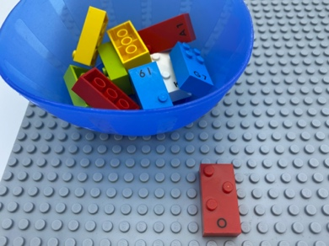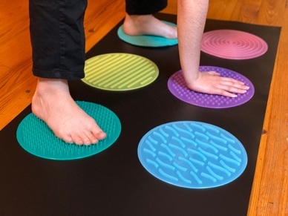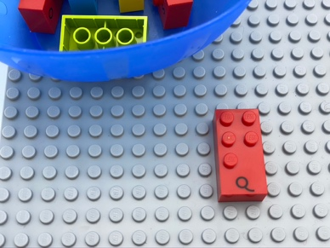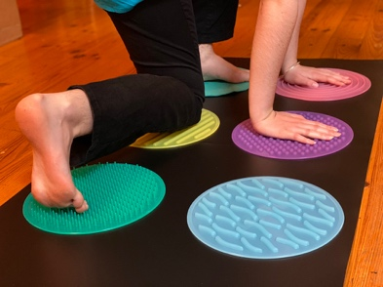

Let’s play
- Pick a brick from the bowl and place it on the base plate.
- Feel the dots on the brick and their pattern: we call this the constellation of dots.
- Copy the constellation of dots by touching the corresponding discs on the floor with different parts of your body (e.g. hands, feet, elbow etc.).

How to prepare
- 1 base plate
- 5 different bricks
- 1 bowl
- 6 different textured discs (minimum 8-inch diameter)
Arrange the 6 discs on the floor, like a braille cell and tape them.
Place the bricks in the bowl.

Facilitation tips
- Try some preliminary exercises playing with the braille cell:
- Can you place a hand on dot 5?
- Can you place a foot on dot 3?
- Can you place your head on dot 4?
- Can you place a knee on dot 6?
- Can you tell me which dot my hand is on?
- Can you put two hands in different dots? ...
- Ask “What parts of your body can you use to make the constellation?”
- The discs can be made out of different material and are preferable to tiles because their shape reminds us of round braille dots.
- Confusion between dot’s position in the braille cell, how we represent numbers in braille and the number of dots in the constellation can be avoided by saying “dot 2” and not only “2”.

Possible variations
- Change number of studs on bricks.
- Peer play: one child is in charge of dots 1, 2, 3 the other dots 4, 5, 6; use several cells, …

Children will develop these holistic skills
- PHYSICAL - Coordinate several motor skills in one activity
Develop motor skills and build body language
- COGNITIVE - Recognize body parts
Use numbers to show a rank, a position

Did you know
- Physical engagement using one's body in learning, helps to better integrate concepts, especially those related to space.
- Inherently joyful and iterative nature of playful activities appears to fuel and boost children’s engagement and learning.

