3 Digit-Number Sorting

15 min 1 participant

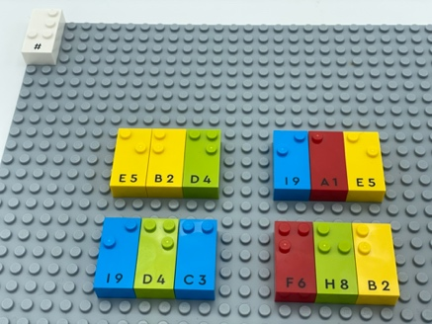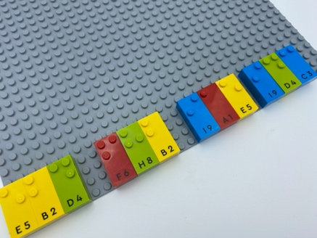

Let’s play
- Read the 4 three-digit numbers on the base plate.
- Move each 3-digit number to the bottom of the base plate from the lowest to the highest number.

How to prepare
- 1 base plate
- All the number bricks
- 1 number sign brick
Place the number sign brick in the top left corner of the base plate to indicate the bricks are numbers.
Write 4 three-digit numbers on the base plate.

Facilitation tips
- Ask “How are you going to organize this task?”
- Reference to the original 4 numbers can be helpful (an identically arranged base plate).

Possible variations
- Change the numbers of digits.
- Change the number of numbers.
- Mix the number of digits.
- Suggest pointing instead of moving bricks.

Children will develop these holistic skills
- COGNITIVE - Use numbers to count, organize, locate, compare
- PHYSICAL - Learn by trial and error, cause and effects, learn to preplan actions
- CREATIVE - Engage in solitary play activities for an appropriate amount of time
- SOCIAL - Anticipate potential problems, identify steps for resolution including alternative solutions

Did you know
- Active participation by children in learning activities, develops their abilities to collect and process acquired knowledge, analyze and handle problems, communicate and cooperate with others.

