Read the Syllable

5 min 1 participant

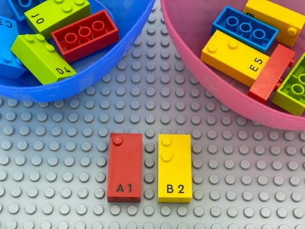

Let’s play
- Pick a brick from each bowl.
- Put your letters together to make a syllable and say it aloud (e.g. 2 possibilities: BA or AB).

How to prepare
- 1 base plate
- 12 bricks (6 different consonants and 6 different vowels)
- 2 bowls
Place the consonants and vowels in separate bowls.

Facilitation tips
- Ask “Can you imagine an animal that can make this sound?”.
- Ask “Can you think of a word starting with or containing this sound?”.

Possible variations
- Increase the number of consonants.
- Take two consonants and one vowel and make a syllable.
- Take more than 2 bricks and read all the syllables as part of an imaginary word.
- Say a syllable out loud and ask the child to spell it out loud or write it down.

Children will develop these holistic skills
- COGNITIVE – Recognize words more and more easily: respond speedily with the correct sound to graphemes (letters or groups of letters)
- CREATIVE - Perform operations on letters and word syllables: remove, add, reverse, locate, substitute
- SOCIAL - Read aloud
- PHYSICAL – Improve auditory discrimination skills: discriminate sounds in words (syllables)
- EMOTIONAL - Understand rules

Did you know
- Braille is a reading system based on a syllabic approach.
- When adults engage children in literacy learning during play, and in a manner that extends rather than interrupts the flow of the play, we do see benefits.

