Identify Dots 1, 2, 3

10 min 1 participant

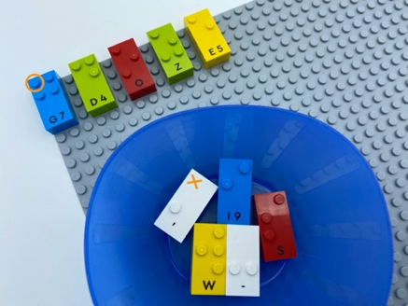

Let’s play
- Find a brick that has a “dot 1” and place it on the base plate. It may have other dots in addition to “dot 1”.
- Repeat the action until you have found all the bricks with “dot1” and placed them on the base plate.

How to prepare
- 1 base plate
- 10 random bricks
- 1 bowl
Place the 10 bricks in the bowl.

Facilitation tips
- Revise the position of the dots in the braille cell with an egg carton.
- Ask “How do you get the brick in the right position?”.
- Confusion between dot’s position in the braille cell, how we represent numbers in braille and the number of dots in the constellation can be avoided by saying “dot 2” and not only “2”.

Possible variations
- Change the number of bricks.
- Change the brick number to be sorted.
- Increase number of dots to be found, e.g. “dot 1” and “dot 2”, …
- Look for bricks without a specific dot number.

Children will develop these holistic skills
- COGNITIVE – Use number to show a rank, a position
- CREATIVE - Spontaneously engage in exploration of different tools and different media
- PHYSICAL - Explore and investigate to get information about the tactual properties of an object
- EMOTIONAL - Follow courteous behavior
- SOCIAL - Comply with directions and limits from adults

Did you know
- To read in braille with efficiency, it is important to have a light touch: the sensory cells of the fingertip should not be crushed in order to get the best sensitive results.
- Physical skills means being physically active, understanding movement and space through practicing sensory-motor skills, developing spatial understanding and nurturing and active and healthy body.

