Twin Friends

10 min 1 participant

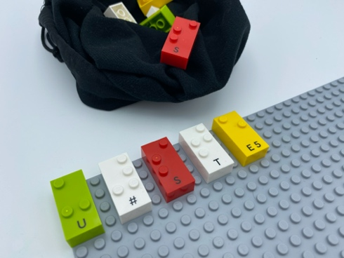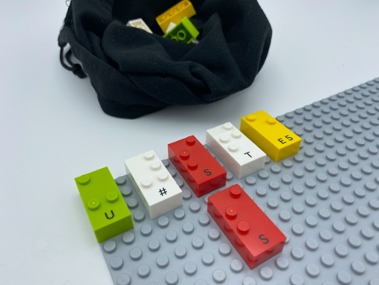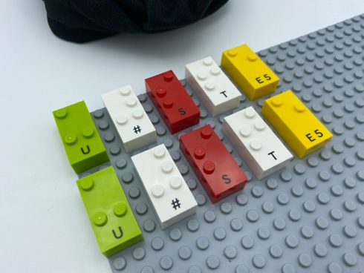

Let’s play
- Feel one brick on the base plate.
- Find the twin brick in the bag.
- Place it under its twin friend.

How to prepare
- 1 base plate
- 5 pairs of bricks: e.g. 2 “S”, 2 “E”, 2 “T", 2 “U", 2 “#”
- 1 small bag
Separate the 5 twin sets of bricks into 2 groups.
On top left of the base plate, align horizontally 5 different bricks. Leave space between them.
Hide the 5 other bricks in the bag.

Facilitation tips
- Encourage exploration of the bricks and counting the studs.

Possible variations
- Increase the number of bricks.
- Add non-matching bricks to the bag.
- Peer play: take turns using the same bag and base plate.

Children will develop these holistic skills
- COGNITIVE - Use the number to show a rank, a position: build a suite identical to a proposed ordered suite
- CREATIVE - Reproduce, assemble, organize, link graphic patterns and then create new ones
- PHYSICAL - Explore and investigate to get information about the tactual properties of an object
Identify spatial relationship within a braille cell, a line, a page

Did you know
- Playing with peers is an inclusive and social interactive activity: it can dissolve barriers!
- Hands-on experimental learning is joyful: children feel able and confident about their learning!
- Using 2 hands to play develops motor skills and proprioception (the process in which nerves are stimulated when the body moves, so that a person is aware of their body's position).

