Frozen Penguins

10 min 1 participant

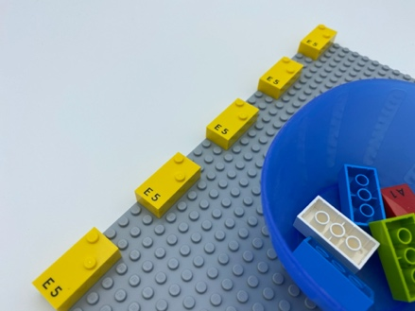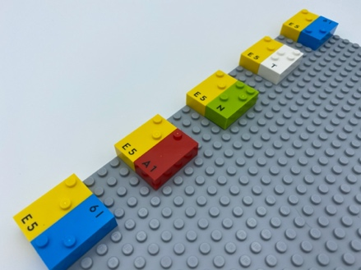

Let’s play
- The 5 frozen penguins on the base plate need a friend to keep them warm.
- Place a penguin from the bowl on the right side, next to each frozen penguin. This will warm the friend up!

How to prepare
- 1 base plate
- 10 random bricks
- 1 bowl
Make a column with 5 vertical bricks on the base plate: start at the top left corner with 1 brick, leave 3 spaces, place a second brick underneath, leave another 3 spaces, place the third brick and so on…. The 5th brick will be in the lower left-hand corner.
Place the 5 other bricks in the bowl.

Facilitation tips
- Encourage child to use both hands.
- Ask child to explain how they determine the difference between the left hand and the right-hand side of the brick.
- Ask “How can you make this activity more fun?”.

Possible variations
- Start with more than 5 bricks on the base plate.
- Add more than one penguin and ask which one is the warmest.
- Place the starter bricks randomly upon the base plate, so the child can add penguins to the left, top or bottom of the starting brick.

Children will develop these holistic skills
- EMOTIONAL - Control motor skills and emotional commitment to succeed in simple actions
- CREATIVE - Reproduce, assemble, organize, link graphic patterns and then create new ones
- COGNITIVE - Recognize spatial relationships
- PHYSICAL – Locate objects by touch: intentionally search for an object
- SOCIAL - Distinguish between personal and collective interests

Did you know
- For a blind child, the acquisition of laterality may be delayed. In order to learn braille, this concept must be known, understood and integrated by the child.
- For young children to progress, early learning practices need to meet them where they are and challenge them to go further.

