Tic Tac Toe

Play with awake and sleeping bricks, to win a game of 3 in a row.
15 min 2 participants

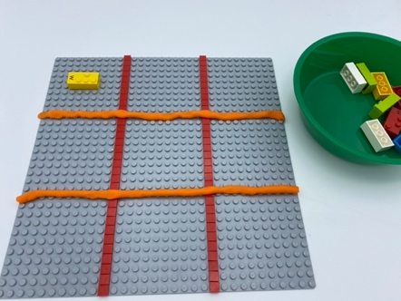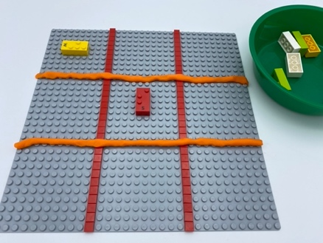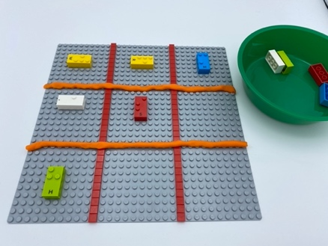

Let’s play
Player 1
- Place an “AWAKE - correct reading position” brick in one of the 9 squares
Player 2
- Place a “SLEEPING” brick in one of the 9 squares
Both players
- Continue playing, until one player WINS by getting 3 bricks in a row (up, down, across, or diagonally)
- If all 9 squares are full, without 3 in a row, the game is over. It is a tie.

How to prepare
- 1 base plate
- 10 random bricks
- 1 bowl
Divide the base plate into 9 squares to create a Tic Tac Toe grid (3x3 squares). Grid can be made using flat or thin LEGO bricks, ropes of playdough, large rubber bands…
Place 10 random bricks in the bowl.

Facilitation tips
- Preliminary exercise: explain the difference between “sleeping” and “awake bricks”
- Try this activity on a raised paper
- Explain the concept of directions: up, down, across, diagonally
- Making a grid that does not merge with the bricks of the game is important so that there is no interference during tactile exploration.

Possible variations
- Increase the size of the board to 4-by-4 (4 in a row), 5-by-5, or even up to a 20-by-20 grid.
- Change the size of the squares, and/or base plate
- Use another kind/shape of LEGO brick for player 2

Children will develop these holistic skills
COGNITIVE - Engage in an approach, observe, question, manipulate, experiment, make hypotheses, by utilizing familiar mathematical tools or procedure
EMOTIONAL - Follow courteous behavior: Interrupt a speaker in a socially acceptable manner when necessary
CREATIVE - Put into words procedures in peer-to-peer exchanges
PHYSICAL - Discover the “spatial organization of a page”: Take reference points in the page
SOCIAL - Engage in game, pretend play activities, verbal play with peers

Did you know
- Cognitive skills - concentration, problem solving, and flexible thinking by learning to tackle complex tasks and building effective strategies to identify solutions.

