Pick Letters, Make Words

30 min 3 participants

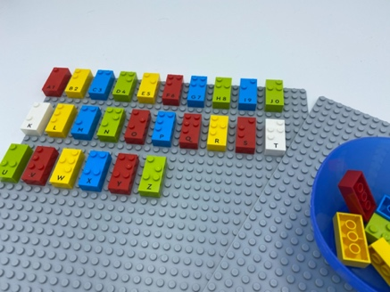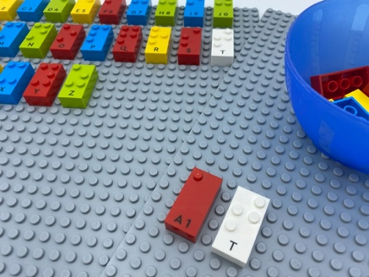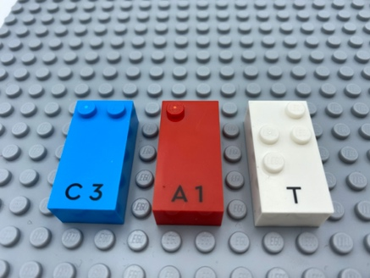

Let’s play
- Pick 2 letters from the bowl.
- Make a word on the base with these letters and any others from the box.
- Read the word.

How to prepare
- 2 base plate
- All the bricks (letters)
- 1 bowl
Select 10 random letters from the box and place them in the bowl.

Facilitation tips
- Before the activity, arrange the additional letters in alphabetical order on the base plate or request the child to do so.
- Suggest “Consider to make this activity more fun”.

Possible variations
- One of the picked letters must be the first letter of the word.
- Increase the difficulty of the letters placed in the bowl (mirror letters, rare letters).
- Find words linked to a specific lesson (vocabulary).

Children will develop these holistic skills
- CREATIVE - Perform operations on letters and word syllables: remove, add, reverse, locate, substitute
- SOCIAL - Participate in discussions, presentations, performances, role play, improvisations and debates: gradually use appropriate vocabulary and/or ratings to describe a situation, present an argument
- COGNITIVE - Locate name in braille
- EMOTIONAL - Solicit information/assistance from appropriate persons in various settings

Did you know
- Learning through Play also involves being actively engaged. Imagine a child who’s fully absorbed in playing with a set of building blocks. He/she is actively imagining how the pieces will go together. This mental immersion and ability to stay focused are especially powerful in the context of Learning through Play.

